School Council’s Report to Governors
Autumn 2020

Over the last few weeks we have made lots of different decisions at the school council meetings.
Week 1: We ranked behaviours from the most severe to least severe. This was to help us make changes to improve the school’s Behaviour Policy. We asked our class to help us.
Week 2: We put the ranked behaviours into 3 groups. We liked the current Styal Goals…

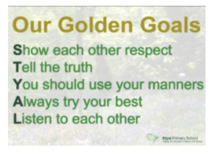
We liked how positive our behaviour policy was. However, children were repeating the same poor behaviours without a clear consequence. We also liked the use of the word goal and so decided to call our 3 groups of behaviours after cards given by a referee in a football match:
- Red card (most severe behaviours)
- Double yellow card
- Yellow card (least severe behaviours)

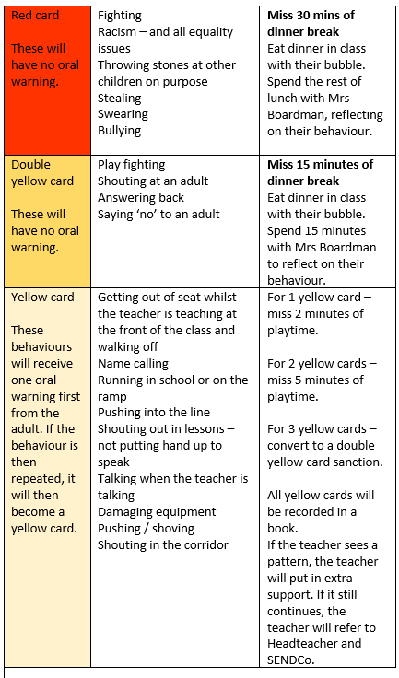

Week 3: Decided the consequences for each behaviour. We decided the colour of the Year 3 4 toilets and shared area in the mobile classrooms. We asked our class for heir opinion.
Week 4: We were asked to find out what our friends in class liked and disliked about school dinners.
April’s mum brought in some stationery donated by Tesco. We were asked to come up with ideas of how to use it best. We decided to use it as prizes for a way to improve handwriting. Miss Yardley is going to start this in January.
Week 5: We thought about what gift Mrs Bellshaw could buy the school as a leaving present.
We discussed if the new school meal options were better and if children liked the new vegetarian options more than last time.

