Styal Primary School
Governor Roles 2023 - 24
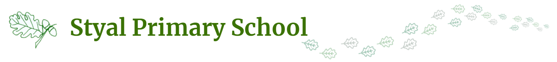

Lee Walsh | Chair of Governors
Natalie Walsh | Vice Chair

F and P Governors
Lee Walsh | Co-opted  Chair of F and P
Chris Novak | Co-opted
Michael Murphy-Pyle | Co-opted
Hana Collins | Parent

L and A Governors
Jennifer Brooks | Co-opted  Chair of L and A
Gemma Pinnington | Co-opted
Helen D’Urso | Co-opted
Amy Yardley | Staff
Natalie Grandison | Parent
Shan Bristow | Co-opted
Lee Whitworth | Local Authority

Link Governors and Committees
Jennifer Brooks | Link governor for foundation subjects
Helen D’Urso | Safeguarding  RSE Link Governor
Lee Walsh  Michael Murphy-Pyle | SFVS
Gemma Pinnington | EYFS Link Governor  SEND Link Governor  EHWB Link Governor
Chris Novak  Helen D’Urso  Michael Murphy-Pyle / Jennifer Brooks | Complaints Committee | Can be adhoc.  Need to be ‘complaints trained within last 3 years’.  If converted to Academy, 3rd governor needs to be a governor from another school.
Michael Murphy-Pyle  Jennifer Brook  Helen D’Urso | Exclusion Committee | Can be adhoc.
Lee Walsh | Premises Walk
Lee Walsh | Health and Safety Walk
Lee Walsh  Helen D’Urso  Gemma Pinnington | Headteachers’ Performance Management Panel
Natalie Grandison | PP and Cared For Children
Lee Walsh  Helen D’Urso  Michael Murphy - Pyle | Pay Review Committee
Lee Walsh | Attendance Link Governor
Natalie Grandison  Chris Novak  Jennifer Brook | Staff Grievance

