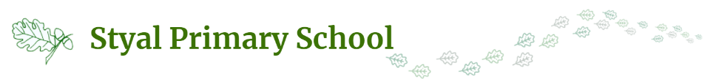
The Impact of Styal Primary School’s Forest School

EHWB
- Know the benefits of being outside
Global Citizenship
- Know why it is important to look after the environment
- Know we have the responsibility to help take care of the local community and wider world
Physical Education
- Balance
- Strength
- Fine motor – tying knots
- Gross motor – lifting and
- Stamina
- Climbing
- Co-ordination
- Using tools safely
Literacy and Language
- New vocabulary
- Speech and language
- Stories
- Information books
- Role play
- Scavenger hunts
Science
- Seasons
- Plants
- Animals including humans
- Habitats
- Senses
- Materials
Art and Design
- Creativity
- Imagination
- Joining materials
- Natural percussion instruments
PSHE
- Resilience
- Risk taking
- Co-operation
- Team work
- Independence
- Self-esteem
- Confidence
Maths
- Measurement
- Estimating
- Comparison
- Problem solving
- Sorting
- Ordering

