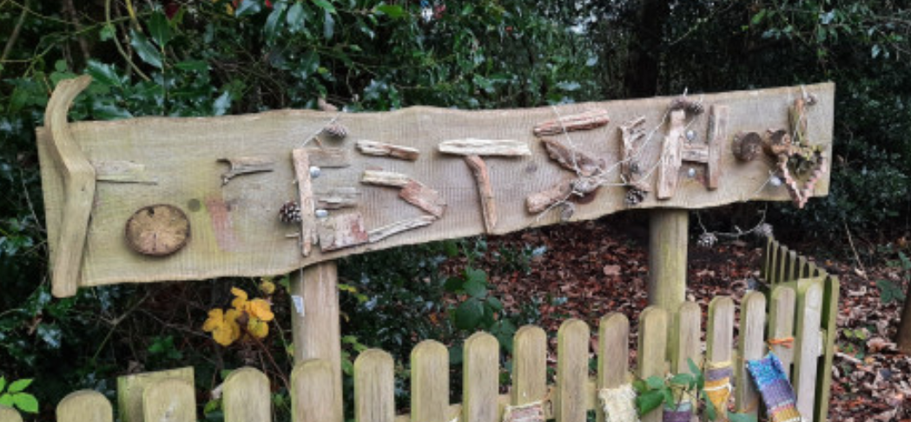
What do our children think about Forest School?
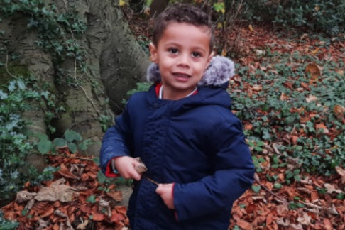
- Forest school is an amazing place where you can learn about nature.
- I love getting the chance to play team games.
- It is a very calm place.
- In forest school you get to use tools (like hammers and saws) that you wouldn’t get to use at home.
- It is a place where you can be creative.
- I love being able to make dens with my friends.
- Building a fire and toasting marshmallows to make s’mores is one of my favourite things.
- Forest school is where you can stop and look around.
- I love looking for different bugs.
