Styal’s Curriculum Pedagogy
At Styal, we use a cognitive science -based approach when deciding the key elements to incorporate into our approach to teaching and learning.
Inclusive Teaching  Children receive ‘high quality teaching’ – good teaching for SEN children is good teaching for all.  - Modelling – explicitly exemplify the learning process to children  - Metacognition  - Scaffolding  - Flexible groupings  - Technology  - Dual coding – using different types of stimuli to help learners encode in their brains more effectively.  - Teaching Reading is at the heart of everything we do | Maths Mastery  - Fluency  - Problem solving / mathematical thinking  - Representation  - Variation  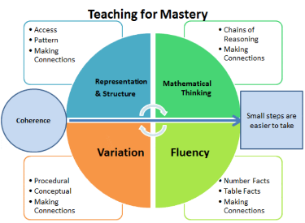  - Coherence | 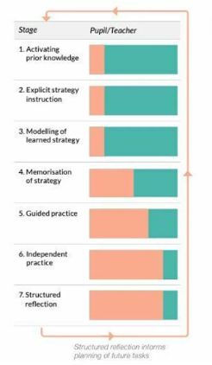  Gradual Release of Responsibility  Scaffolds are available for all and reduced appropriately – moving children towards independence.
Organised Knowledge  Knowledge organisers outline the key knowledge for the subject.  Knowledge is mapped carefully to form a progressive curriculum where learning builds and links well.  Knowledge organisers are child-friendly and support the development of vocabulary. | Purposeful Feedback  - Learning intentions  - Success criteria  - Intervening at the point of learning  - Helicoptering  - Purple polishing  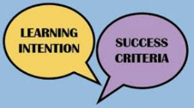 | Working Memory Matters  We think about children’s cognitive load so it is not exceeded. Learning Walls are neutral.  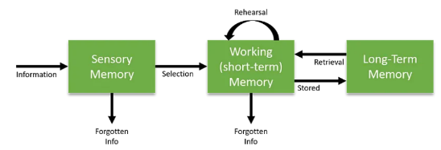  Working memory is supported with ‘bridging back’ and ‘bridging forward’ so clear connections can be made. Retrieval of prior knowledge is supported with low stake quizzes and ‘lag’ quizzes. This ensures that assessment is often and purposeful.

