Styal Primary School

PROGRESSION THROUGH CALCULATIONS
(updated 2021)

The following are standards that we expect the majority of children to achieve. Planning and assessment should be based on the objectives provided by POWER MATHS. however Calculation strategies should always be based on this policy.

By the end of year 6, children will have a range of calculation methods, mental and written. Selection will depend upon the numbers involved.

Children should not be made to go onto the next stage if:

- they are not ready.
- they are not confident.

Children should be encouraged to approximate their answers before calculating.
Children should be encouraged to check their answers after calculation using an appropriate strategy.

ADDITION

MENTAL CALCULATIONS
(ongoing)
These are a selection of mental calculation strategies:

Mental recall of number bonds
6 + 4 = 10 + 3 = 10
25 + 75 = 100 19 + = 20

Use near doubles
6 + 7 = double 6 + 1 = 13

Addition using partitioning and recombining
34 + 45 = (30 + 40) + (4 + 5) = 79

Counting on or back in repeated steps of 1, 10, 100, 1000
86 + 57 = 143 (by counting on in tens and then in ones)
460 - 300 = 160 (by counting back in hundreds)

Add the nearest multiple of 10, 100 and 1000 and adjust
24 + 19 = 24 + 20 – 1 = 43
458 + 71 = 458 + 70 + 1 = 529

Use the relationship between addition and subtraction
36 + 19 = 55 19 + 36 = 55
55 – 19 = 36 55 – 36 = 19

MANY MENTAL CALCULATION STRATEGIES WILL CONTINUE TO BE USED. THEY ARE NOT REPLACED BY WRITTEN METHODS.

Key language which should be used: sum, total, parts and wholes, plus, add, altogether, more than, ‘is equal to’ ‘is the same as’

EYFS and Key Stage One
YR and Y1

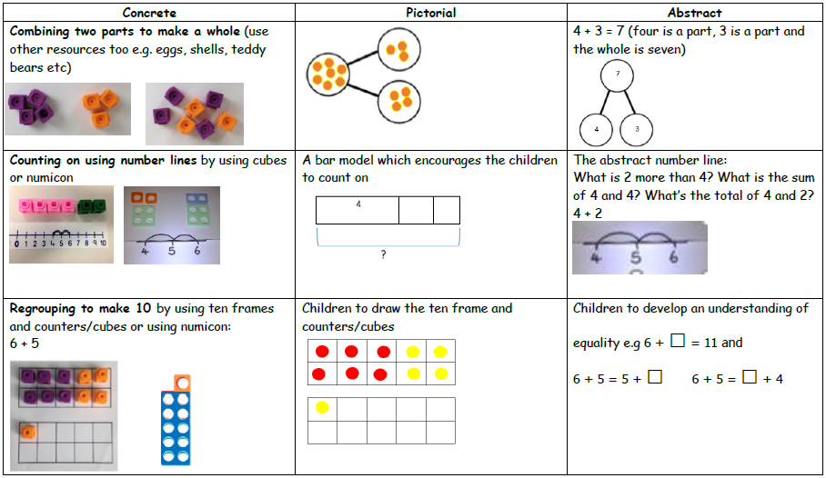

Y2

Children will begin to use ‘empty number lines’ themselves starting with the larger number and counting on.

First counting on in tens and ones.

34 + 23 = 57
+10
+10

+1
+1
+1

34 44 54 55 56 57

Then helping children to become more efficient by adding the ones in one jump (by using the known fact 4 + 3 = 7).

34 + 23 = 57
+10
+10

+3

34 44 54 57

Followed by adding the tens in one jump and the ones in one jump.

34 + 23 = 57
+20
+3

34 54 57

Bridging through ten can help children become more efficient.

37 + 15 = 52
+10
+2
+3

37 47 50 52

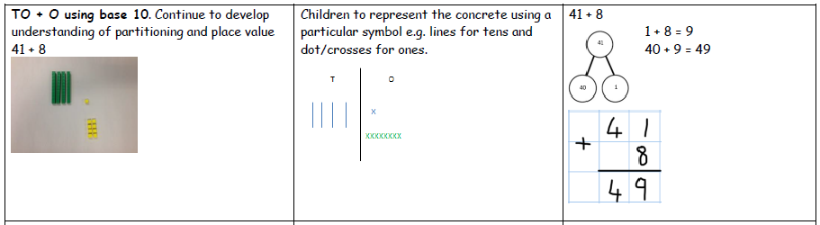

Children may be able to move onto 2 digit add 2 digit involving no carrying

Key Stage 2
Y3+4

Children will continue to use empty number lines with increasingly large numbers.

Count on from the largest number irrespective of the order of the calculation.

38 + 86 = 124
+30
+4
+4

86 116 120 124

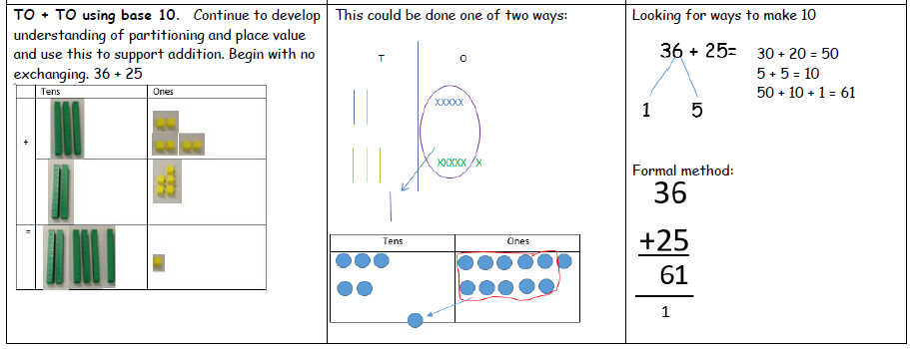

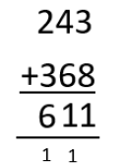
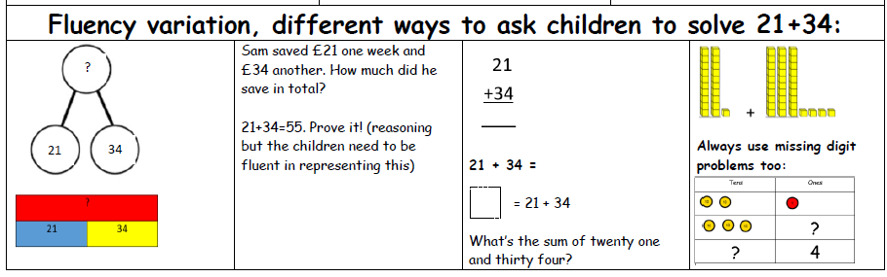

Using similar methods, children will:
- add several numbers with different numbers of digits;
- add up to 4 digit numbers
- begin to add two or more three-digit sums of money, with or without adjustment from the pence to the pounds;
- know that the decimal points should line up under each other, particularly when adding or subtracting mixed amounts, e.g. £3.59 + 78p.

Y 5+6
Children should then extend the carrying method to numbers with at least four digits.

587 3587
+ 475 + 675
1062 4262
¹ ¹ ¹ ¹ ¹

Using similar methods, children will:
- add several numbers with different numbers of digits;
- begin to add two or more decimal fractions with up to three digits and the same number of decimal places;
- know that decimal points should line up under each other, particularly when adding or subtracting mixed amounts, e.g. 3.2 m – 280 cm.

Children should then extend the carrying method to numbers with any number of digits.

7648 6584 42
+ 1486 + 5848 6432
9134 12432 786
¹ ¹ ¹ ¹ ¹ ¹ 3
+ 4681 11944
¹ ² ¹

Using similar methods, children will
- add several numbers with different numbers of digits;
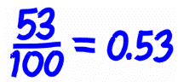
- begin to add two or more decimal fractions with up to four digits and either one or two decimal places;

- know that decimal points should line up under each other, particularly when adding or subtracting mixed amounts, e.g. 401.2 + 26.85 + 0.71.

SUBTRACTION
MENTAL CALCULATIONS
(ongoing)
These are a selection of mental calculation strategies:

Mental recall of addition and subtraction facts
10 – 6 = 4 17 - = 11
20 - 17 = 3 10 - = 2

Find a small difference by counting up
82 – 79 = 3

Counting on or back in repeated steps of 1, 10, 100, 1000
86 - 52 = 34 (by counting back in tens and then in ones)
460 - 300 = 160 (by counting back in hundreds)

Subtract the nearest multiple of 10, 100 and 1000 and adjust
24 - 19 = 24 - 20 + 1 = 5
458 - 71 = 458 - 70 - 1 = 387

MANY MENTAL CALCULATION STRATEGIES WILL CONTINUE TO BE USED. THEY ARE NOT REPLACED BY WRITTEN METHODS.

EYFS and Key Stage One
YR and Y1

Children are encouraged to develop a mental picture of the number system in their heads to use for calculation. This is taught through Nursery rhymes and practical resources such as toy ducks. They develop ways of recording calculations using pictures etc.
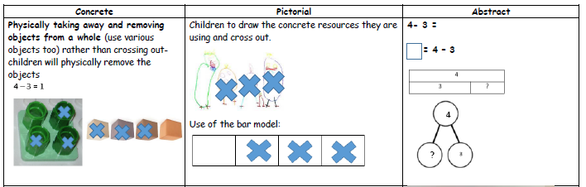
They use numberlines and practical resources to support calculation. Teachers demonstrate the use of the numberline. Calculations begin using numbers up to 5 then with numbers up to 10. When children are solid with numbers up to 10 they will progress to numbers up to 20.
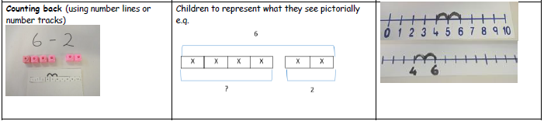

Y2

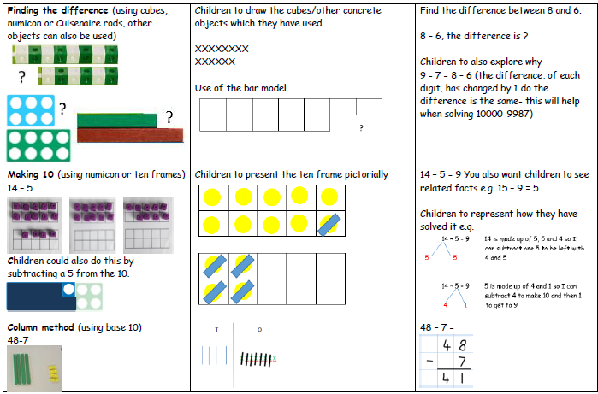
Children will begin to use empty number lines to support calculations.

Counting on or back

It can be more efficient to count on.

Count up from 47 to 82 in jumps of 10 and jumps of 1.

The number line should still show 0 so children can cross out the section from 0 to the smallest number. They then associate this method with ‘taking away’.

82 - 47
+10
+1
+1
+10
+10
+1
+1
+1

0 47 48 49 50 60 70 80 81 82

Help children to become more efficient with counting on by:

- Subtracting the ones in one jump;
- Subtracting the tens in one jump and the ONEs in one jump;
- Bridging through ten.

Progression through KS2

Calculations should be solved using the below methods only and with progressively harder numbers as per National Curriculum.

Children will continue to use empty number lines with increasingly large numbers.

Children should know that ones line up under ones, tens under tens, and so on.

Where the numbers are involved in the calculation are close together or near to multiples of 10, 100 etc counting on using a number line should be used.
This method should also be used for time.

102 – 89 = 13
+10

+1
+2

0 89 90 100 102

If children are more solid in their understanding of one particular method then they should be allowed to use this method as their preferred method for any subtraction calculation. All children should become efficient in at least one method.

Column Method
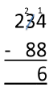

Children should:
- be able to subtract numbers with different numbers of digits;
- using this method, children should also begin to find the difference between two three-digit sums of money, with or without ‘adjustment’ from the pence to the pounds;
- know that decimal points should line up under each other.

Where the numbers are involved in the calculation are close together or near to multiples of 10, 100 etc counting on using a number line should be used.

511 – 197 = 314
+300

+11
+3

0 197 200 500 511

Bar Method and other visual representations should be used to demonstrate and model the concept
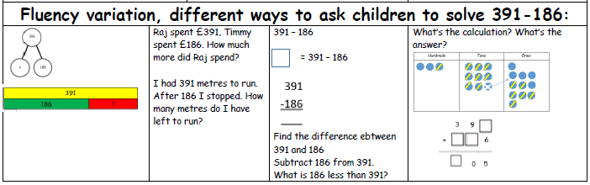

MULTIPLICATION
MENTAL CALCULATIONS
(ongoing)
These are a selection of mental calculation strategies:

Doubling and halving

Knowing that halving is dividing by 2

Deriving and recalling division facts

Tables should be taught everyday from Y2 onwards, either as part of the mental oral starter or other times as appropriate within the day.

Year 2 2 times table
3 times table
5 times table
10 times table

Year 3 Recap 2,5,10
4 times table
8 times table
3 times table
6 times table

Year 4 Derive and recall division facts for all tables up to 12 x 12

Year 5 & 6 Derive and recall quickly division facts for all tables up to 12 x 12

Multiplying by 10 or 100
Knowing that the effect of multiplying by 10 is a shift in the digits one place to the left.
Knowing that the effect of multiplying by 100 is a shift in the digits two places to the left.

MANY MENTAL CALCULATION STRATEGIES WILL CONTINUE TO BE USED. THEY ARE NOT REPLACED BY WRITTEN METHODS.

Key language which should be used: double times, multiplied by, the product of, groups of, lots of, ‘is equal to’ ‘is the same as’

EYFS and Key Stage One
YR and Y1

Children will experience equal groups of objects and will count in 2s, 10s and 5s. They will work on practical problem solving activities involving equal sets or groups.

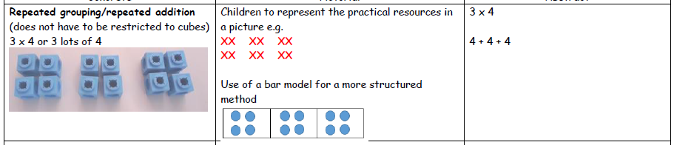

Y2

Children will develop their understanding of multiplication and use jottings to support calculation:

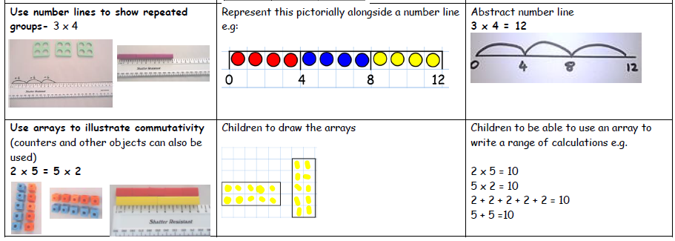

Key Stage 2
Y3+4
Children will continue to use:
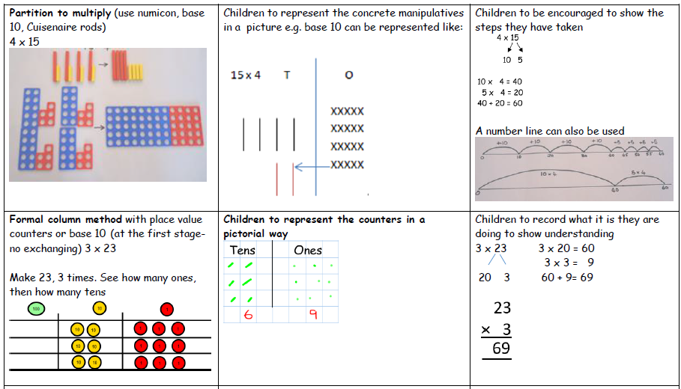
Using symbols to stand for unknown numbers to complete equations using inverse operations

x 5 = 20 3 x = 18 x = 32

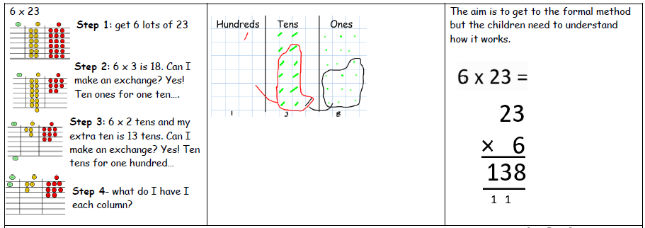
Y5 +6
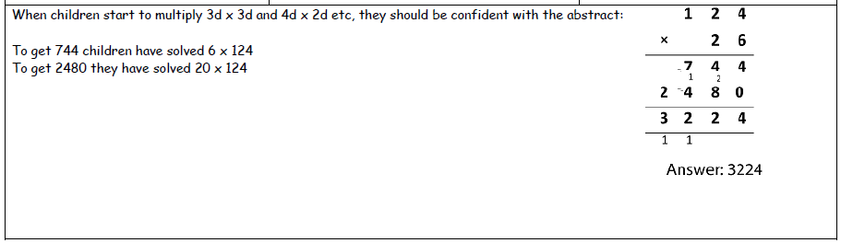

Children should be able to multiply proper fractions and mixed numbers by whole numbers
supported by materials and diagrams.
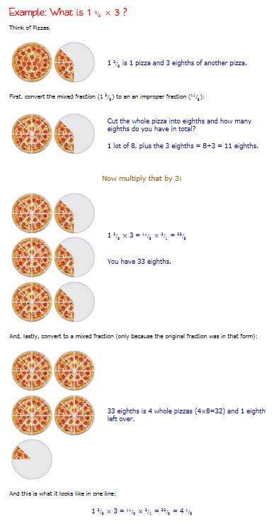

Using similar methods, they will be able to multiply decimals with up to two decimal places by a single digit number and then two digit numbers, approximating first. They should know that the decimal points line up under each other.

For example:

4.92 x 3
Children will approximate first
4.92 x 3 is approximately 5 x 3 = 15

Children should be able to multiply simple pairs of proper fractions.

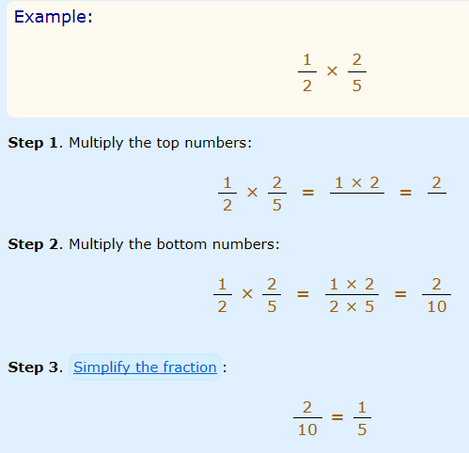

DIVISION

MENTAL CALCULATIONS
(ongoing)
These are a selection of mental calculation strategies:

Doubling and halving

Knowing that halving is dividing by 2

Deriving and recalling division facts

Tables should be taught everyday from Y2 onwards, either as part of the mental oral starter or other times as appropriate within the day.

Year 2 2 times table
3 times table
5 times table
10 times table

Year 3 Recap 2,5,10
4 times table
8 times table
3 times table
6 times table

Year 4 Derive and recall division facts for all tables up to 12 x 12

Year 5 & 6 Derive and recall quickly division facts for all tables up to 12 x 12

Dividing by 10 or 100

Knowing that the effect of dividing by 10 is a shift in the digits one place to the right.
Knowing that the effect of dividing by 100 is a shift in the digits two places to the right.

Key language: share, group, divide, divided by, half, is equal to, is the same as

EYFS and Key Stage One

YR and Y1

Children will understand equal groups and share items out in play and problem solving.

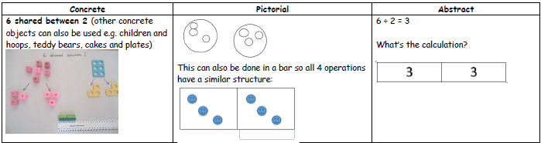

Y2

Children will develop their understanding of division and use jottings to support calculation

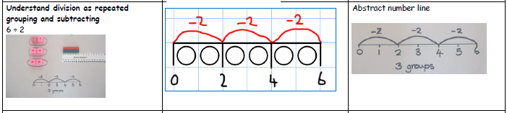

Key Stage Two

Y3 + 4

Children will continue to use:

Repeated subtraction using a number line

Children will use an empty number line to support their calculation.

24 ÷ 4 = 6

0 4 8 12 16 20 24

Children should also move onto calculations involving remainders.

13 ÷ 4 = 3 r 1

4 4 4

0 1 5 9 13

Children will develop their use of repeated subtraction to be able to subtract multiples of the divisor. Initially, these should be multiples of 10s, 5s, 2s and 1s – numbers with which the children are more familiar.

72 ÷ 5

-2 -5 -5 -5 -5 -5 -5 -5 -5 -5 -5 -5 -5 -5 -5

0 2 7 12 17 22 27 32 37 42 47 52 57 62 67 72

Moving onto:
-50
-5
-5
-5
-5
10
r2

_______________________________________________________
1
1
1
1

0 2 7 12 17 22 72

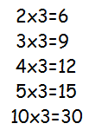
Then onto the vertical method WITH A FACT BOX:

Short division TO ÷ O

72 ÷ 3

3 ) 72
- 30 10x
42
- 30 10x
12
- 6 2x
6
- 6 2x
0

Answer : 24

Leading to subtraction of other multiples.
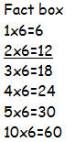
96 ÷ 6

1 6
6 ) 96
- 60 10x
36
- 36 6x
0

Answer : 16

Any remainders should be shown as integers, i.e. 14 remainder 2 or 14 r 2.

Children need to be able to decide what to do after division and round up or down accordingly. They should make sensible decisions about rounding up or down after division. For example 62 ÷ 8 is 7 remainder 6, but whether the answer should be rounded up to 8 or rounded down to 7 depends on the context.

e.g. I have 62p. Sweets are 8p each. How many can I buy?
Answer: 7 (the remaining 6p is not enough to buy another sweet)

Apples are packed into boxes of 8. There are 62 apples. How many boxes are needed?
Answer: 8 (the remaining 6 apples still need to be placed into a box)

Y5+6

Children will continue to use written methods to solve short division :
TO ÷ O
HTO ÷ O

Children can start to subtract larger multiples of the divisor, e.g. 30x
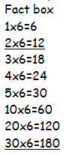
Short division HTO ÷ O

196 ÷ 6
32 r 4
6 ) 196
- 180 30x
16
- 12 2x
4

Answer : 32 remainder 4 or 32 r 4

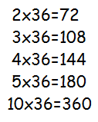
Long division HTO ÷ TO

972 ÷ 36
27
36 ) 972
- 720 20x
252
- 252 7x
0

Answer : 27

Any remainders should be shown as fractions, i.e. if the children were dividing 32 by 10, the answer should be shown as 3 ²/₁₀ which could then be written as 3 ¹/₅ in it’s lowest terms.

Extend to decimals with up to two decimal places. Children should know that decimal points line up under each other.

When children are secure with chunking (long division) then they will learn Bus Stop to solve 1 digit by multiple digit divisions.
