**Parents of Styal Newsletter**

01

ISSUE

September  
2018

Welcome

We would like to say a big welcome to the new families who have come to Styal this year and we look forward to meeting everyone.

Thank you

A big thank you to the previous members of the POS who did an amazing job for the children of Styal.

Who’s who in the committee

Chair - Julie Robertson

Vice Chair – Louise Vose

Treasurer – Alex Round

Secretary – Grace Brosnan

Teacher rep – Mrs Jacobs

Contact

[parentsofstyal@gmail.com](mailto:parentsofstyal@gmail.com)

We hope to produce this newsletter every two months and if you miss the email it can be found on the school website under POS.

This Issue

Welcome and who’s who

What is the POS

News

Events

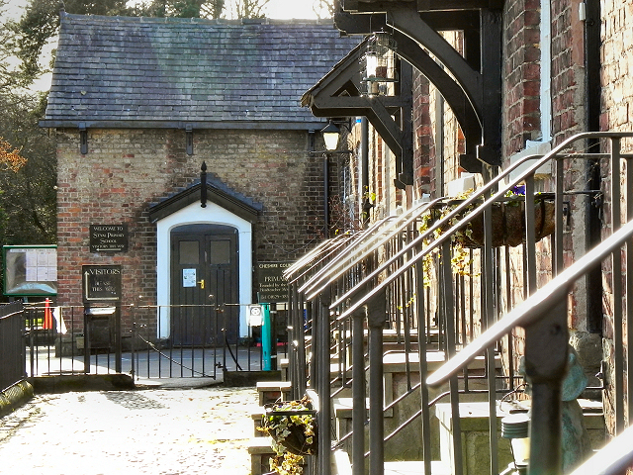

POS

Every parent/carer is a part of POS and therefore ideas and involvement are very welcome. We hold meetings termly and all parents/carers are welcome to attend.

As well as hosting events for the children/family’s enjoyment we also raise money for vital items for school. In previous years the POS has raised money to fund the sensory sparkle room, school stage, computer equipment, gymnastic equipment, outdoor seating area, parasols, forest school equipment, mobile cooker and most recently the new outdoor flooring for the reception area. All of these important extras help make our school such a wonderful and special place for our children to attend.

News

Children’s Xmas card designs will be available for online ordering from 7th – 16th November. Please consider purchasing these as they do raise money for school funds.

Events

We are looking forward to an exciting year at Styal and we would like to remind parents that the events we put on will need volunteers.

It has been suggested this year that as well as generally raising funds for the school we will look at raising funds for specific projects, these include, Kits for the various teams, computers, greenhouse, sports hall etc. If you have any ideas please feel free to contact us and put your ideas forward.

29th Sept – Foot golf, styal golf club (TBC)

25th Oct – Halloween Disco

16th Dec 4pm – Carols and Christingle

19th June 2019 - Summer Ball

Future plans

Christmas Fair

Bar and BBQ beach party (TBC)