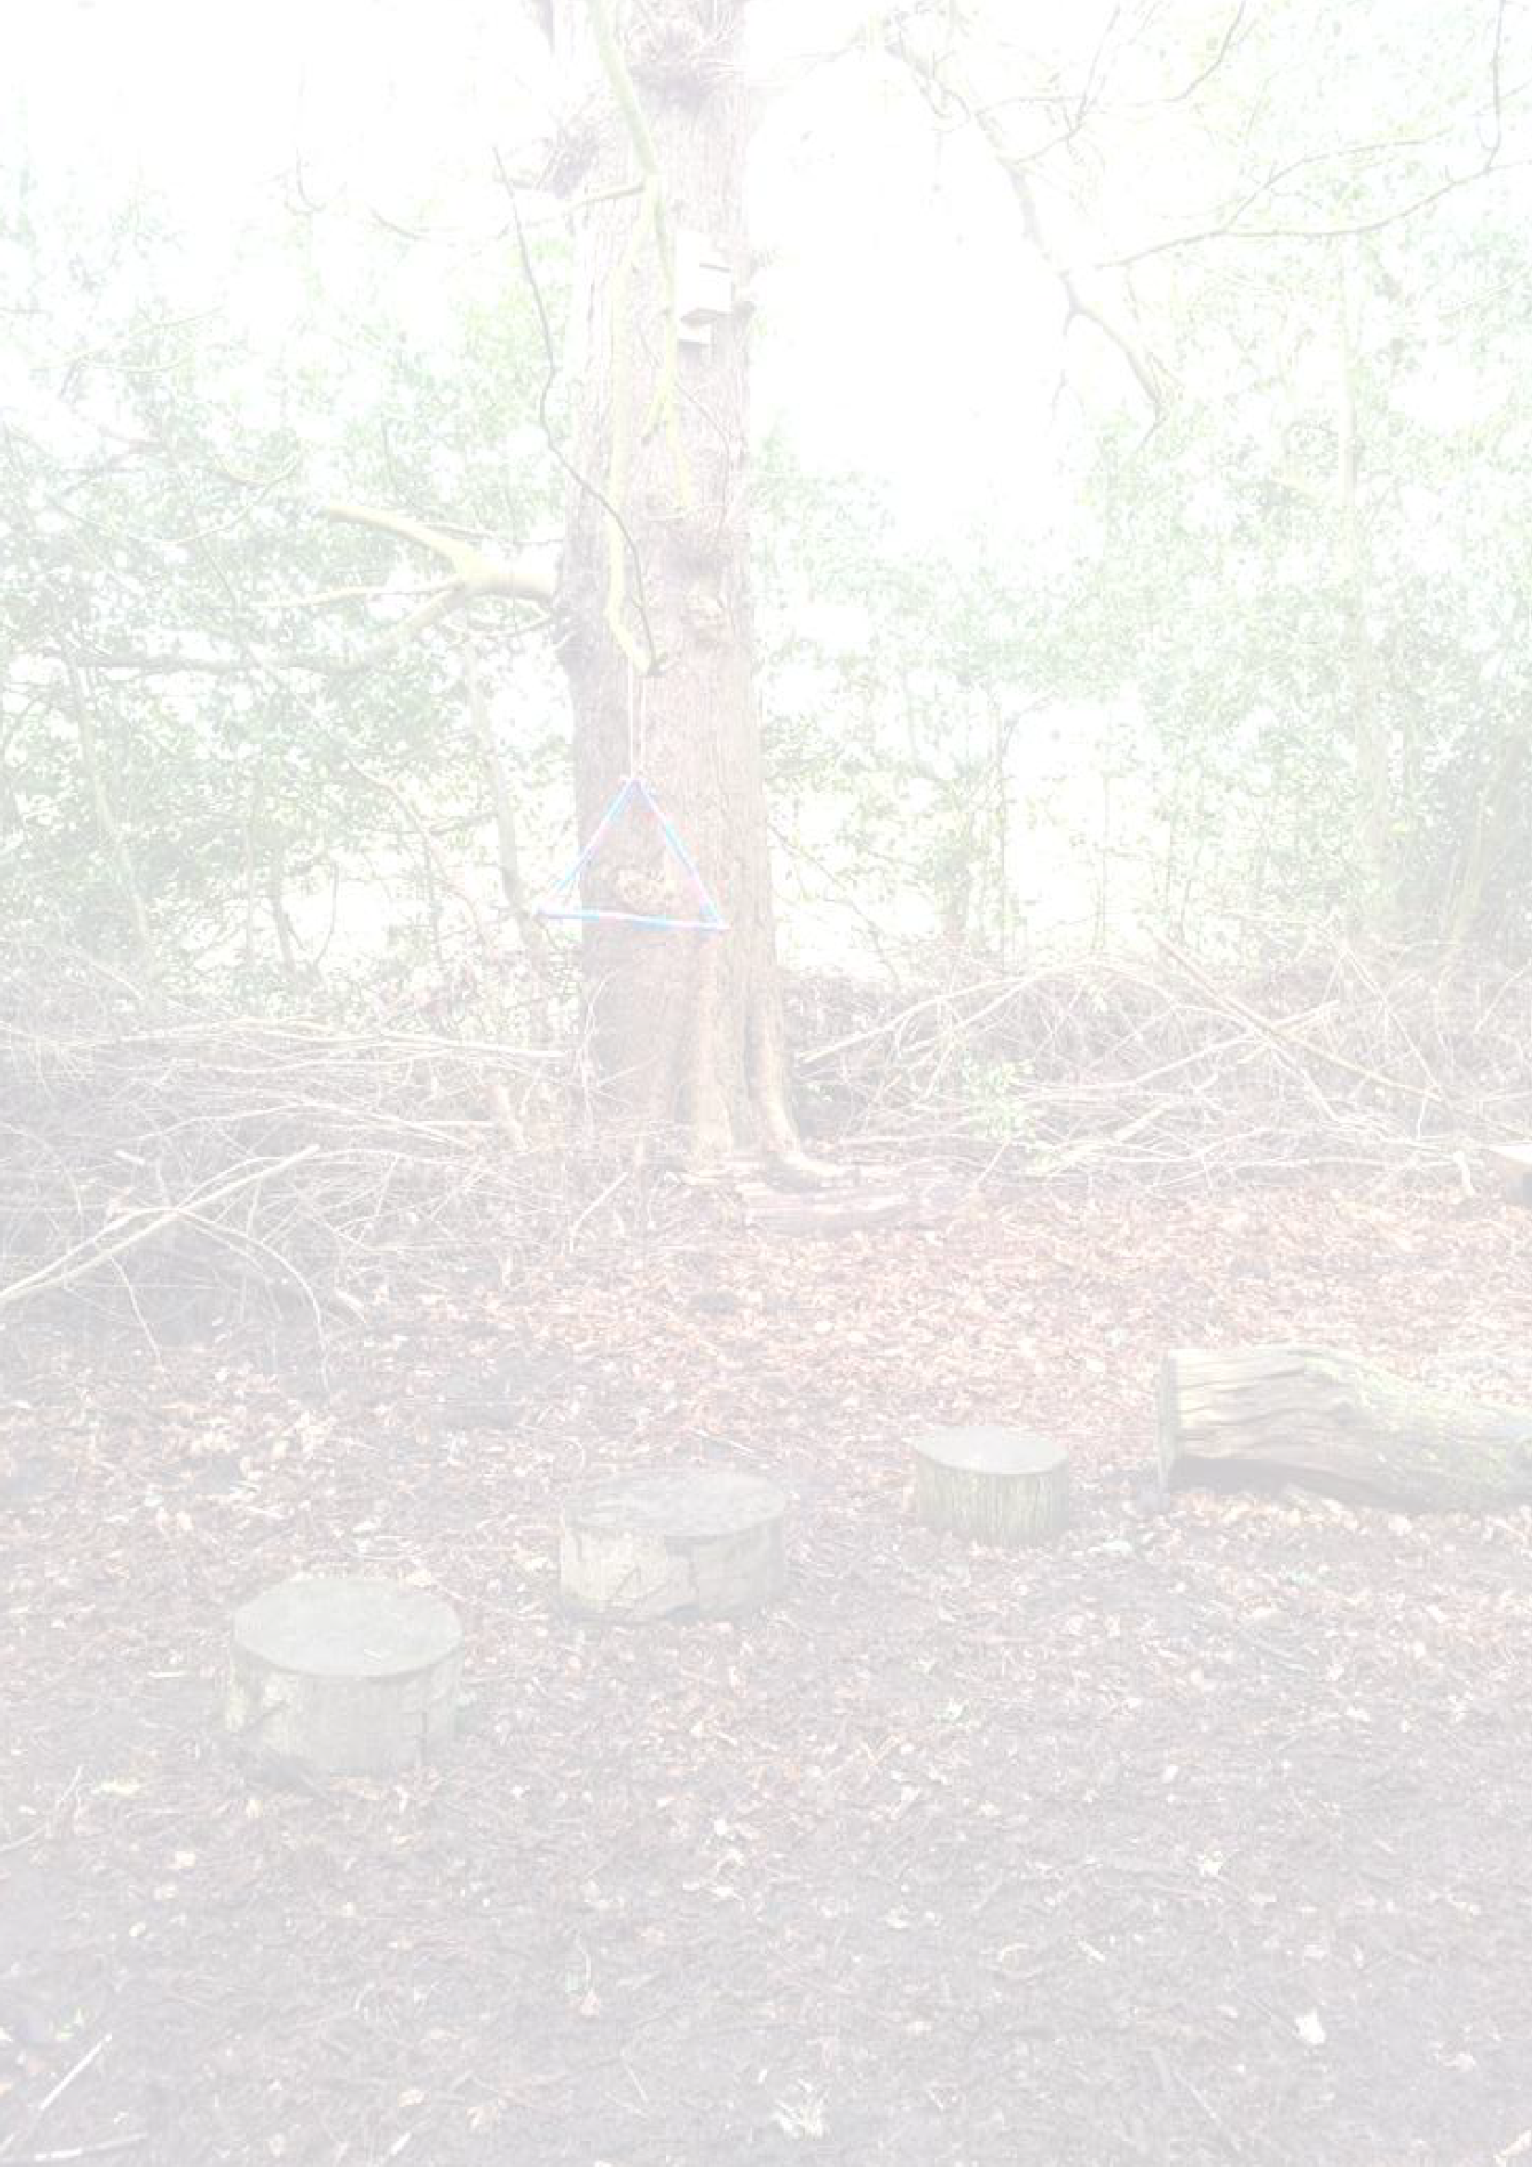
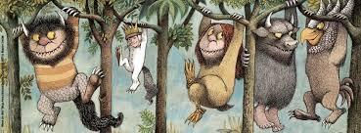
Styal Primary School 2023 - 24
Styal Primary Forest School Handbook

1

To be read by all adult leaders, volunteers and visitors attending Forest School sessions.

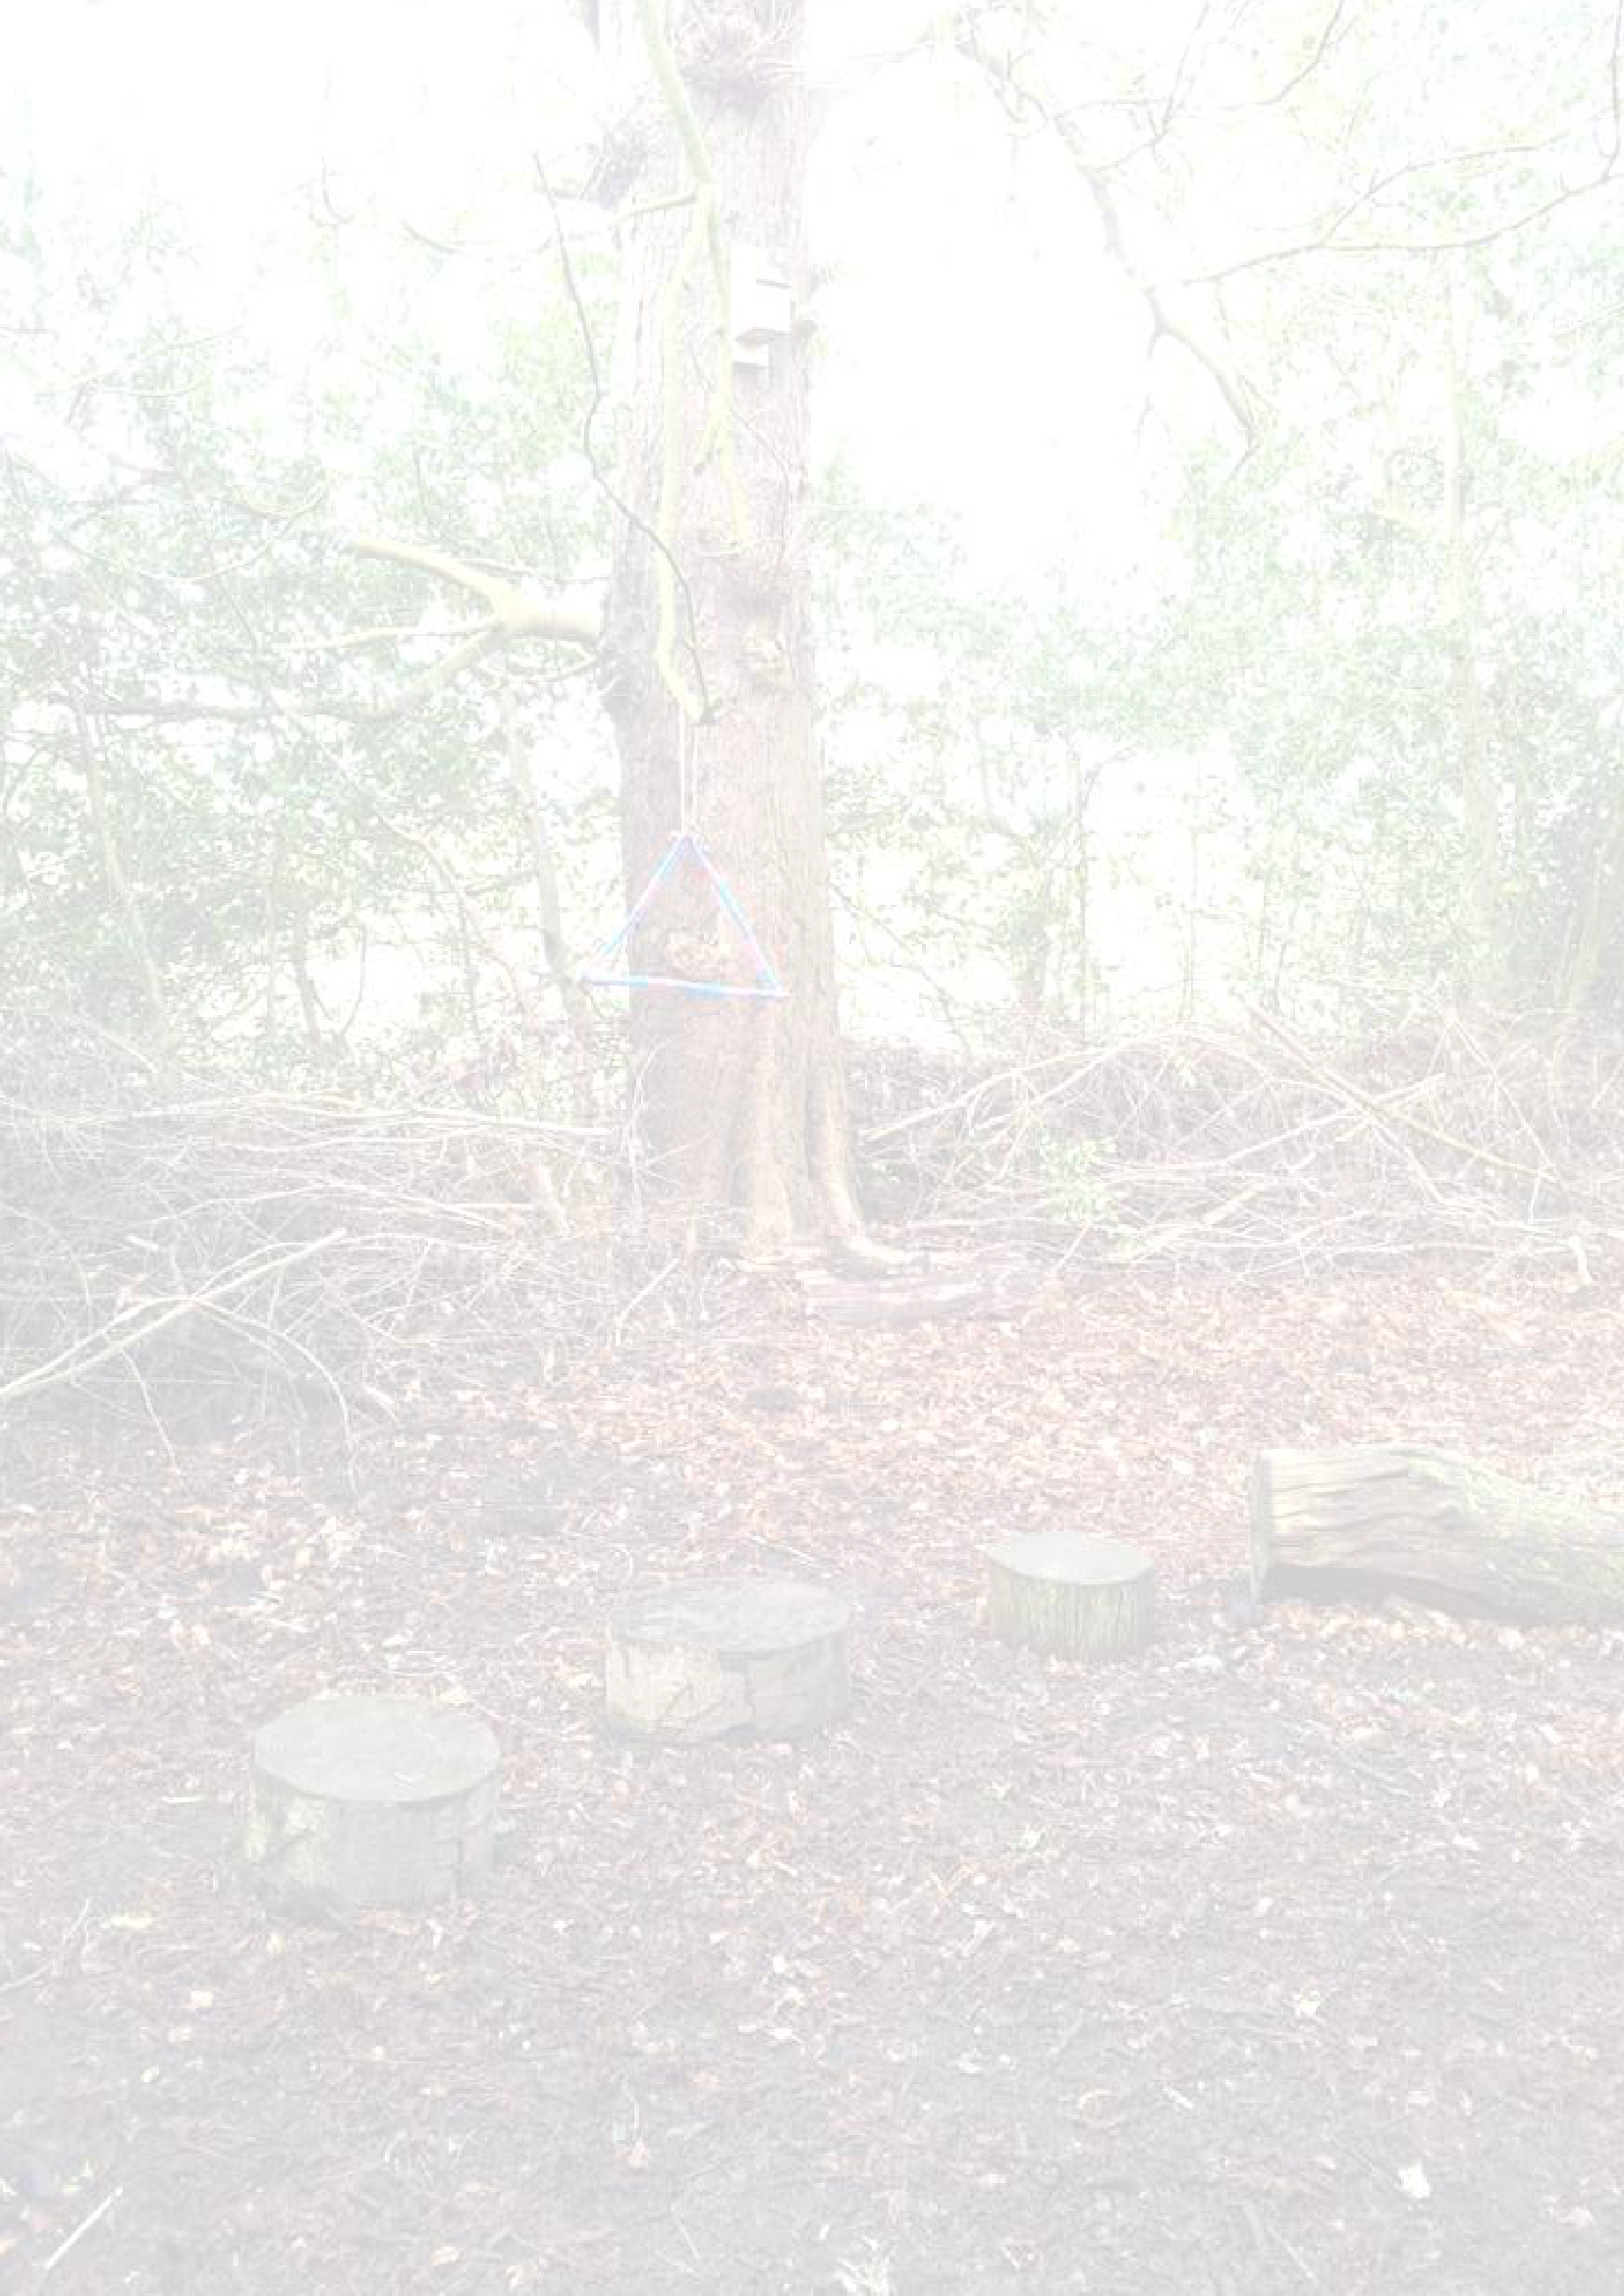
Contents Page
Styal Primary Forest School Handbook

2

Forest School Site Information Page 3
Forest School Ethos Page 4
Forest School Code of Conduct Page 5
Forest School Site Summary Page 8
Session Procedures Page 9
Essential Items Page 10
Health and Safety Page 11
Risk Assessment Page 15
Environmental Impact Assessment Page 16
Clothing List for Children Page 18
Travel Policy Page 19
Designated Person Page 19
Using and Storing Tools Page 20
Poor Weather Conditions Page 22
Appendix 1 – Safety Sweep Pro forma Page 23
Appendix 2 - Risk Assessment Page 24

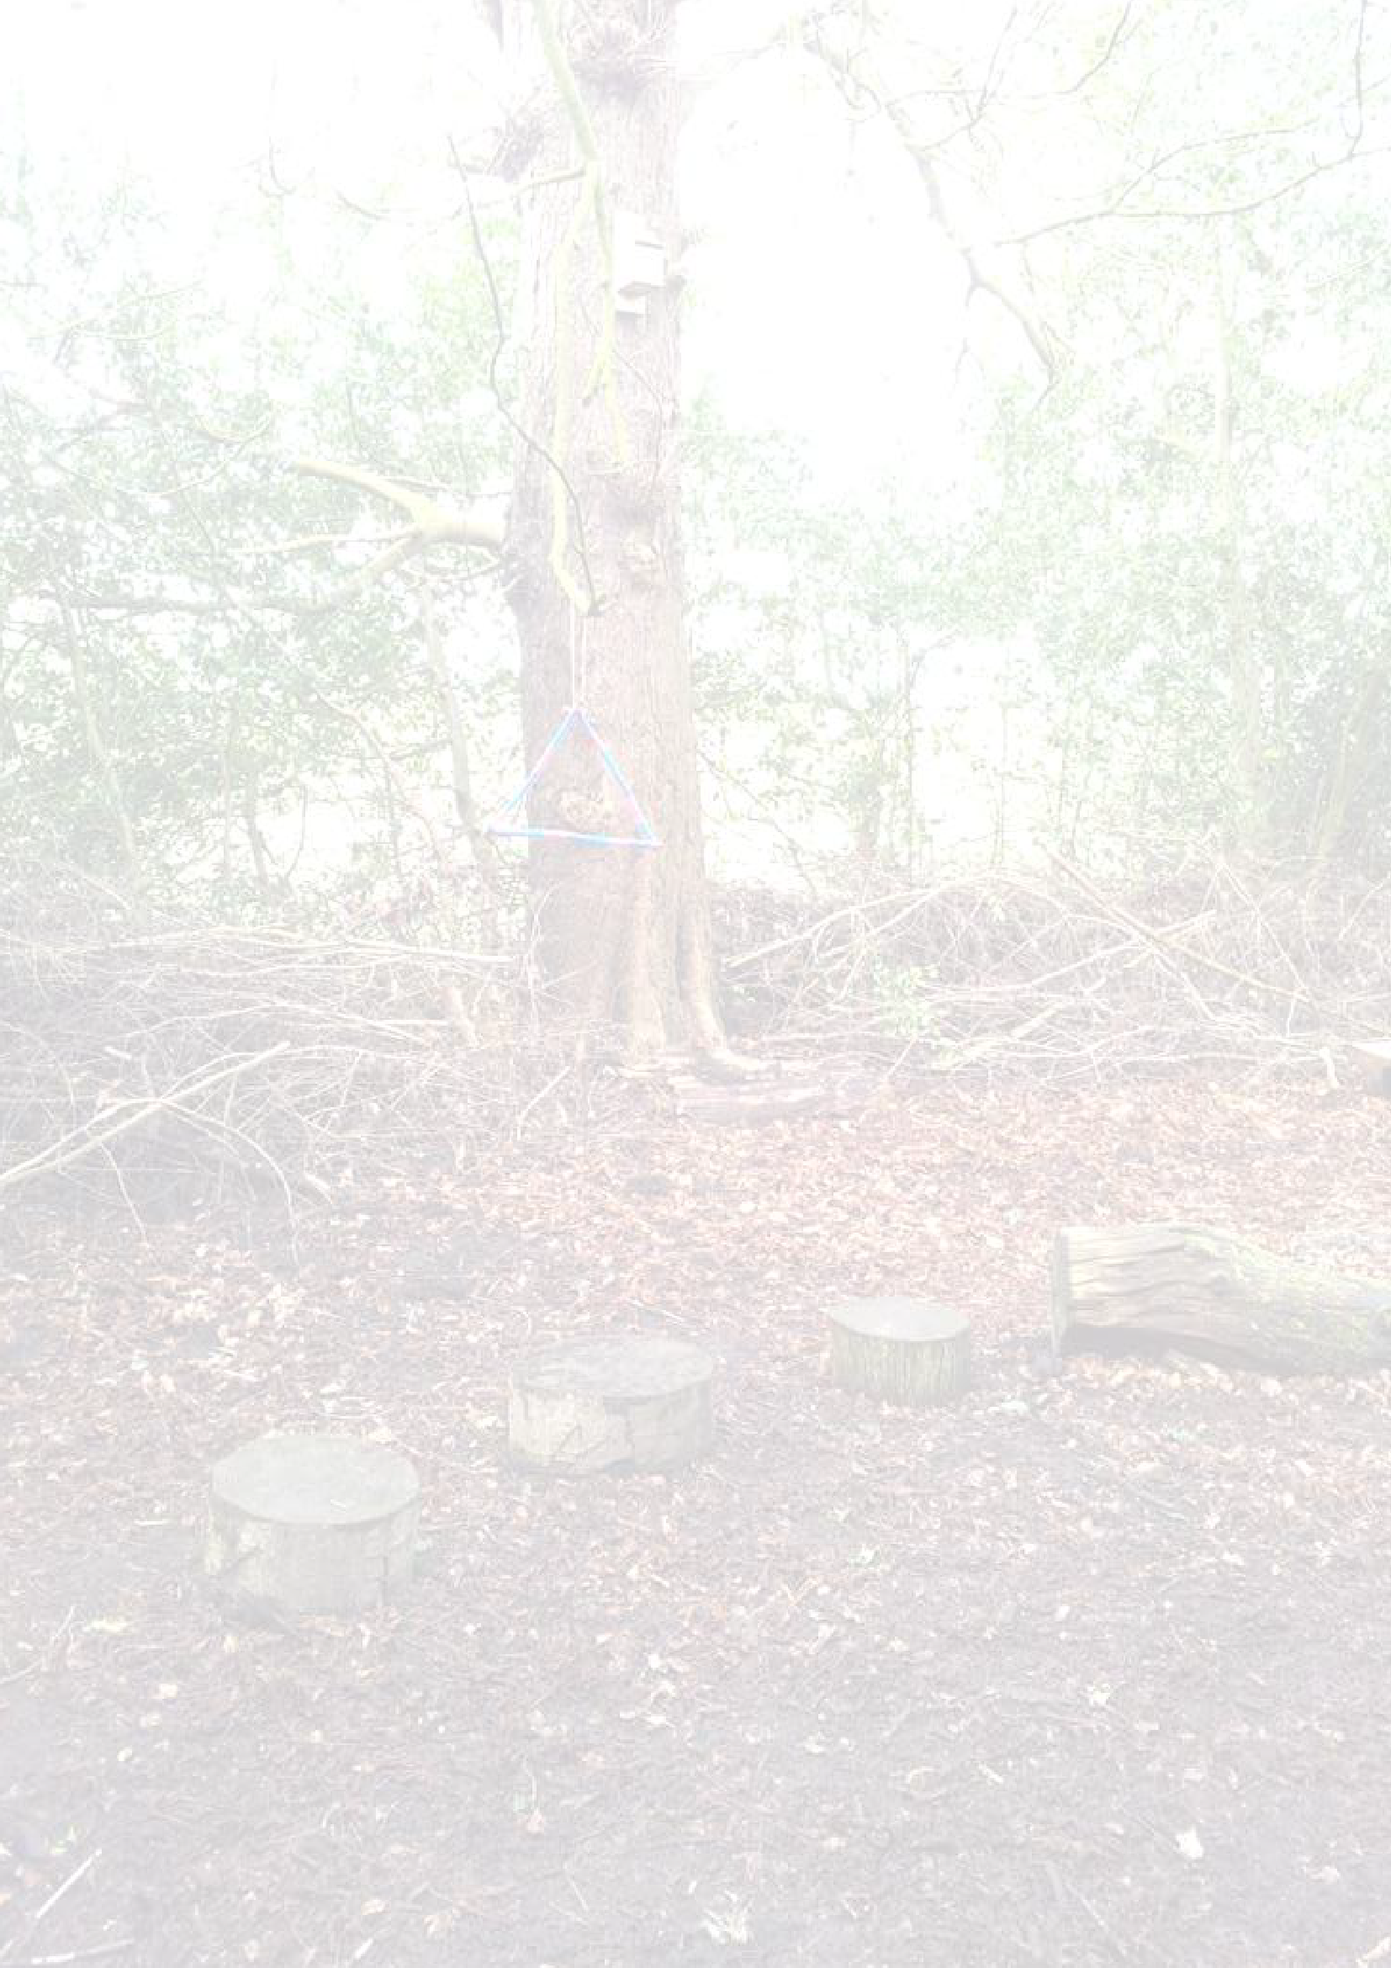
Forest School Site Information
Styal Primary Forest School Handbook

3
Access to the site is via the locked gate at the right-hand side of the playing field (as you are standing with your back to the school).
The gate can be unlocked using the standard padlock key.
In an emergency, access can also be gained around the back of Norcliffe Chapel or from the log store area at the back of the mobiles (next to the staff car park).
Emergency vehicles are to follow the sign situated on Altrincham Road for ‘Emergency Vehicles’ and make their way to the electronic double gates (or the staff car park if able to direct them as this is quicker access).

School telephone number: 01625 917280 Postcode: SK9 4JE
Ordnance survey grid reference: SJ 83390 83496
Latitude: 53.348095
Longitute: -2.2509715

Forest School Ethos
Styal Primary Forest School Handbook

4

“We need the tonic of wildness... We can never have enough of nature.”
Henry David Thoreau
The Forest School approach to learning can be summarised as one which puts the child at the centre of their own learning. It is the child who makes the decisions about which activities to participate in, how to approach and solve problems, what they need to reflect on, what their strengths are and what they want to learn next. All of this is achieved in our richest of classrooms – the outdoors.

Children are given room to have real life experiences. They are encouraged to think ‘outside of the box’; make mistakes; direct their own learning and take risks. All of these factors culminate in producing children who have increased confidence levels, developed independence, raised self-esteem, great communication skills, resilience and high levels of motivation.

Education should be all about experiences because that is when learning is optimised. Benjamin Franklin could not have phrased it better when he said: “Tell me and I forget, teach me and I may remember, involve me and I learn”.

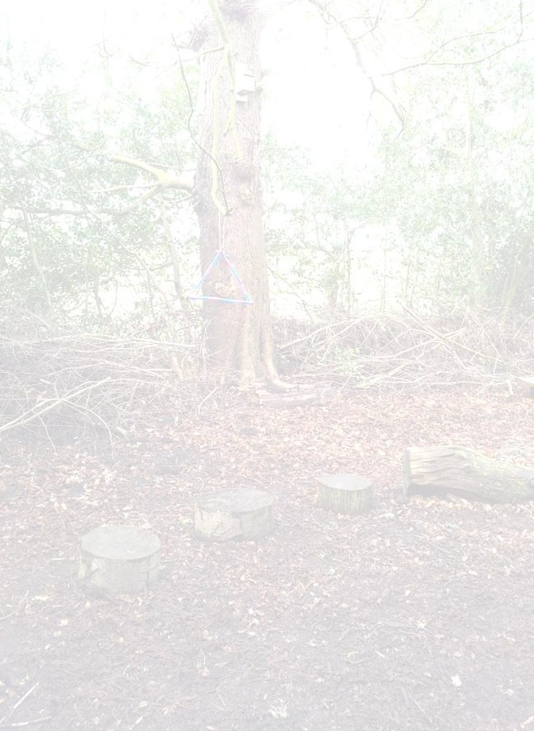
Forest School Code of Conduct
Styal Primary Forest School Handbook

5

General Code of Conduct during Forest School sessions:
- No running
- Return to Base Camp when an adult shouts: ‘1,2,3 where are you?’ or makes the ‘duck call’.
- Never throw any objects
- Respect each other Boundaries
Boundaries in the Forest School area will always be clearly marked with blue rope. Children will know not to go beyond these areas. If a child is lost sight of, then shout ‘1, 2, 3, where are you?’ The child should reply ‘1, 2, 3 I’m over here’. This strategy has been introduced to the children through a game and practised many times.

Picking up and playing with sticks
Children can carry sticks no longer than their arm’s length but they must make sure that they think about how close they are to other children. Longer sticks can be dragged or carried with a child at both ends. Sticks must not be thrown, nor should children be allowed to pull them from living trees.

Tree climbing
Adult:child ratio must be 1:1. Check ground cover for sharp objects and check ‘climbing trees’ for loose and rotten branches. Children are allowed to explore to their own limits but an adult will intervene if they feel that their choices are unsafe. Children will not be allowed to climb higher than your arm reach.

Rope and string use
Styal Primary Forest School Handbook

6
Encourage connecting and transporting materials. Prevent tying up other children or themselves. If a child has a good idea and wants, for example, to try to build a rope swing do help them and use the chance to model appropriate knot tying.

Carrying & transporting materials
The children should be encouraged to roll, lift, drag and pull materials, either by hand or using ropes. The safe way to lift, by bending your knees and keeping a straight back should be modelled by all adults. Heavier objects can be rolled, dragged or carried by more people.

Toileting
Children are always encouraged to use the toilets before we leave the school. School toilets are close enough for children to be taken to by a responsible adult.

Eating and drinking
Our ‘No picking, no licking’ motto will apply at all times.
Prevent children eating anything found in woods, such as berries or seeds. Keep reminding them about fingers and hands in mouths and noses. If we take drinks or snacks outside ensure children use wipes to clean their hands first.

Base camp
Base Camp is a circular area, in the middle of the Forest School site, demarcated by tree stumps (which are a safe distance apart so that children can whittle when seated upon them). There is a fire square marked out by 4 logs in the centre – children must not enter the fire square.
Children will learn to always go around the Base Camp area – even if there is no
fire lit. This will be reinforced through games. The seating area is ‘tumbling distance’ from the fire pit. Children will only enter the circle if they are asked to do so by an adult and this will only ever be a maximum of 2 children at a time.

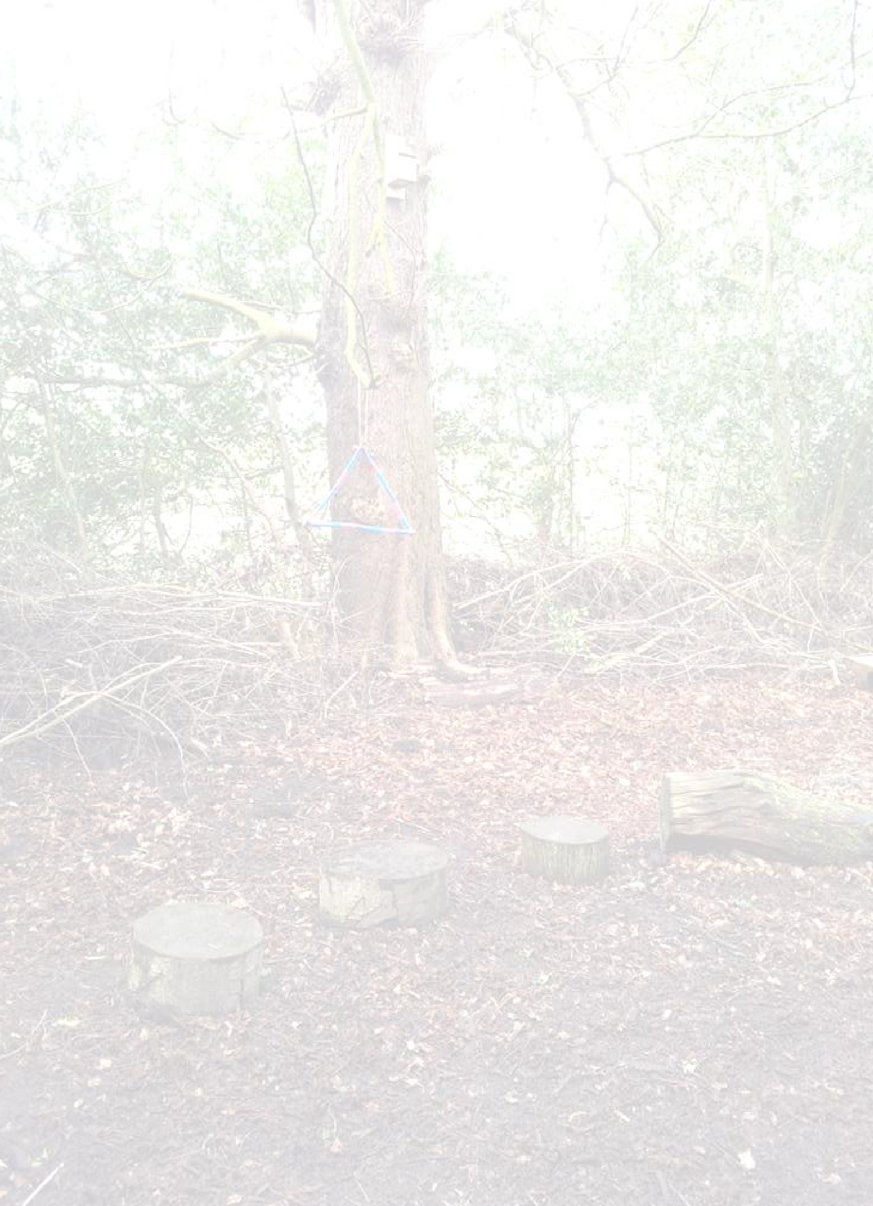
Leaving the site
Styal Primary Forest School Handbook

7
We will respect our ‘Take only photos, leave only footprints’ motto and will always aim to leave the site as we found it. We must always make sure that there is nothing visible to the public from our boundary rope, as agreed by ourselves and the National Trust.

Collecting fire wood
We have cleared it with the National Trust that we have access to any of the dead wood within the area.
Wood should be collected in three thicknesses – matchstick size, pencil size and thumb thickness. This is a great sorting activity for the children and not as easy as it sounds!

Lighting a fire
The FS leader will take control of this and all accompanying adults will be briefed before we start. Children will be taught how to build fires, use fire steels, make ‘paper doughnuts’, use ‘fairy blankets’ and light fires but this will always be under very close supervision and on a 1:1 basis. They will always be water, fire gloves and a burns kit next to the base camp area.

Forest School Site Summary
Styal Primary Forest School Handbook

8
Our Forest School area:

- is leased to us;
- is situated at the back of the school playing field;
- can be entered through a padlocked gate;
- is open to the public, however due to its somewhat hidden location it does not have any real traffic passing through it;
- is frequented by smaller fauna such as rabbits, hedgehogs, badgers, foxes and squirrels;
- features a number of trees, including beech, yew, horse chestnut and holly;
- features a mixture of flora including ferns, brambles and nettles, although the brambles and nettles are regularly cut back;
- has no access for vehicles;
- has no running or standing water;
- has a designated fire pit area and the rules regarding this have been explained to the children.

Forest School Session Procedures
Styal Primary Forest School Handbook

9
- The Forest Leader will sweep the woodland area before the beginning of each session to ensure that it is safe for the children.
- Prior to the session all children will be encouraged to visit the toilet and change into appropriate clothing for the weather.
- On our way to Forest School we will sing our Forest School song.
- Children will enter the woodland respectfully and calmly and after carrying out their own ‘Safety Sweep’ will take a seat in base camp.
- Throughout the session the children will be encouraged to initiate their own play/learning with a balance of completing the challenges suggested.
- At the end of the session the group will meet back at Base Camp to share their experiences.
- We will sometimes end our session with a campfire.
- The children will all help to tidy away all resources and equipment at the end of the session.
- Tools will be counted back in.
- The campfire will be extinguished properly.
- After leaving the woodland area the children will wash their hands and then change back into their school uniform.

Essential Items
Styal Primary Forest School Handbook

10

The following items will be taken out to every Forest School session:
  - Emergency bag containing: First Aid kit and Burns kit (both to be checked weekly and restocked as appropriate); bottle of drinking water; bivi bag; roll mat; contact details of everyone attending (including the adults); chocolate/sugary food and accident sheets
  - Emergency whistle
  - Medication specific to children attending the session (if not appropriate for the individual to look after their own medication then it will be clearly labelled and placed in the orange backpack which will always be hung on the tree next to Base Camp)
  - Forest School handbook, which features emergency procedures and risk assessments
  - Large container of water to put out the fire
  - Mobile phone should be taken
  - Wet wipes and hand gel

Health and Safety
Styal Primary Forest School Handbook

11
Styal Primary School’s ‘Health and Safety Policy’ covers the whole school approach to the safety of its children, staff and visitors. However, Forest School programmes are likely to include activities which are considered higher risk than usual. We will seek to minimise risk by following appropriate procedures for more risky activities, such as tool use and fires, and by carrying out risk assessments covering key hazards which the children may come into contact with.

Staffing considerations:
  - The Forest School leaders, Miss Tompkins and Miss McClendon, hold the Level 3 Forest School qualification as well as an Outdoor Paediatric First Aid certificate.
  - There will always be another member of staff in attendance at Forest School.
  - All additional adults will have their DBS check.
  - All adults helping in the forest must read the handbook and then sign and date the handbook inside cover to confirm this.

Area considerations:
  - The woodland area has been checked carefully and a risk assessment has been carried out. This will be reviewed quarterly to reflect the changes in the seasons.
  - A thorough sweep of the area will be completed by the Forest School leader prior to each session (Appendix 1).
  - Any animal excretion found during the sweep will be removed.
  - Expectations and boundaries are made clear to the children.

  - There are no obvious slopes or ditches in the woodland area.
Styal Primary Forest School Handbook

12
  - There are 3 yew trees in the area. The children will be educated about not eating anything from the wood and we have a ‘No Picking, No Licking’ motto.
  - The area is leased to us by the National Trust. We have met with a NT ranger to explore specific site issues and discuss their terms and conditions.
  - Styal School have taken out appropriate liability insurance. Equipment considerations:
- The safety of all equipment will be checked on a weekly basis.
- Children will always be dressed appropriately. In warm weather it will still be a requirement that their legs are kept covered.

Emergency procedures:
- In case of an emergency an adult will blow the emergency whistle 3 times and the children will congregate in the grassy area at the back of the Reception classroom (this area is next to the Forest School).
- The qualified First Aider (who is also the Forest School leader) will attend to any casualties with adult helper and with regard for maintenance of required supervision ratios for the rest of the party. At least one first aider must be on site at all times. A record of changes in casualties’ state and anything administered to them to be made if possible.
- If necessary the emergency services will be contacted by the school office. A charged mobile phone will be taken to every session. (See page 3). A designated adult will be sent to meet the emergency vehicle at the entrance leading off Altrincham Road. Give the following information to the 999 operator:

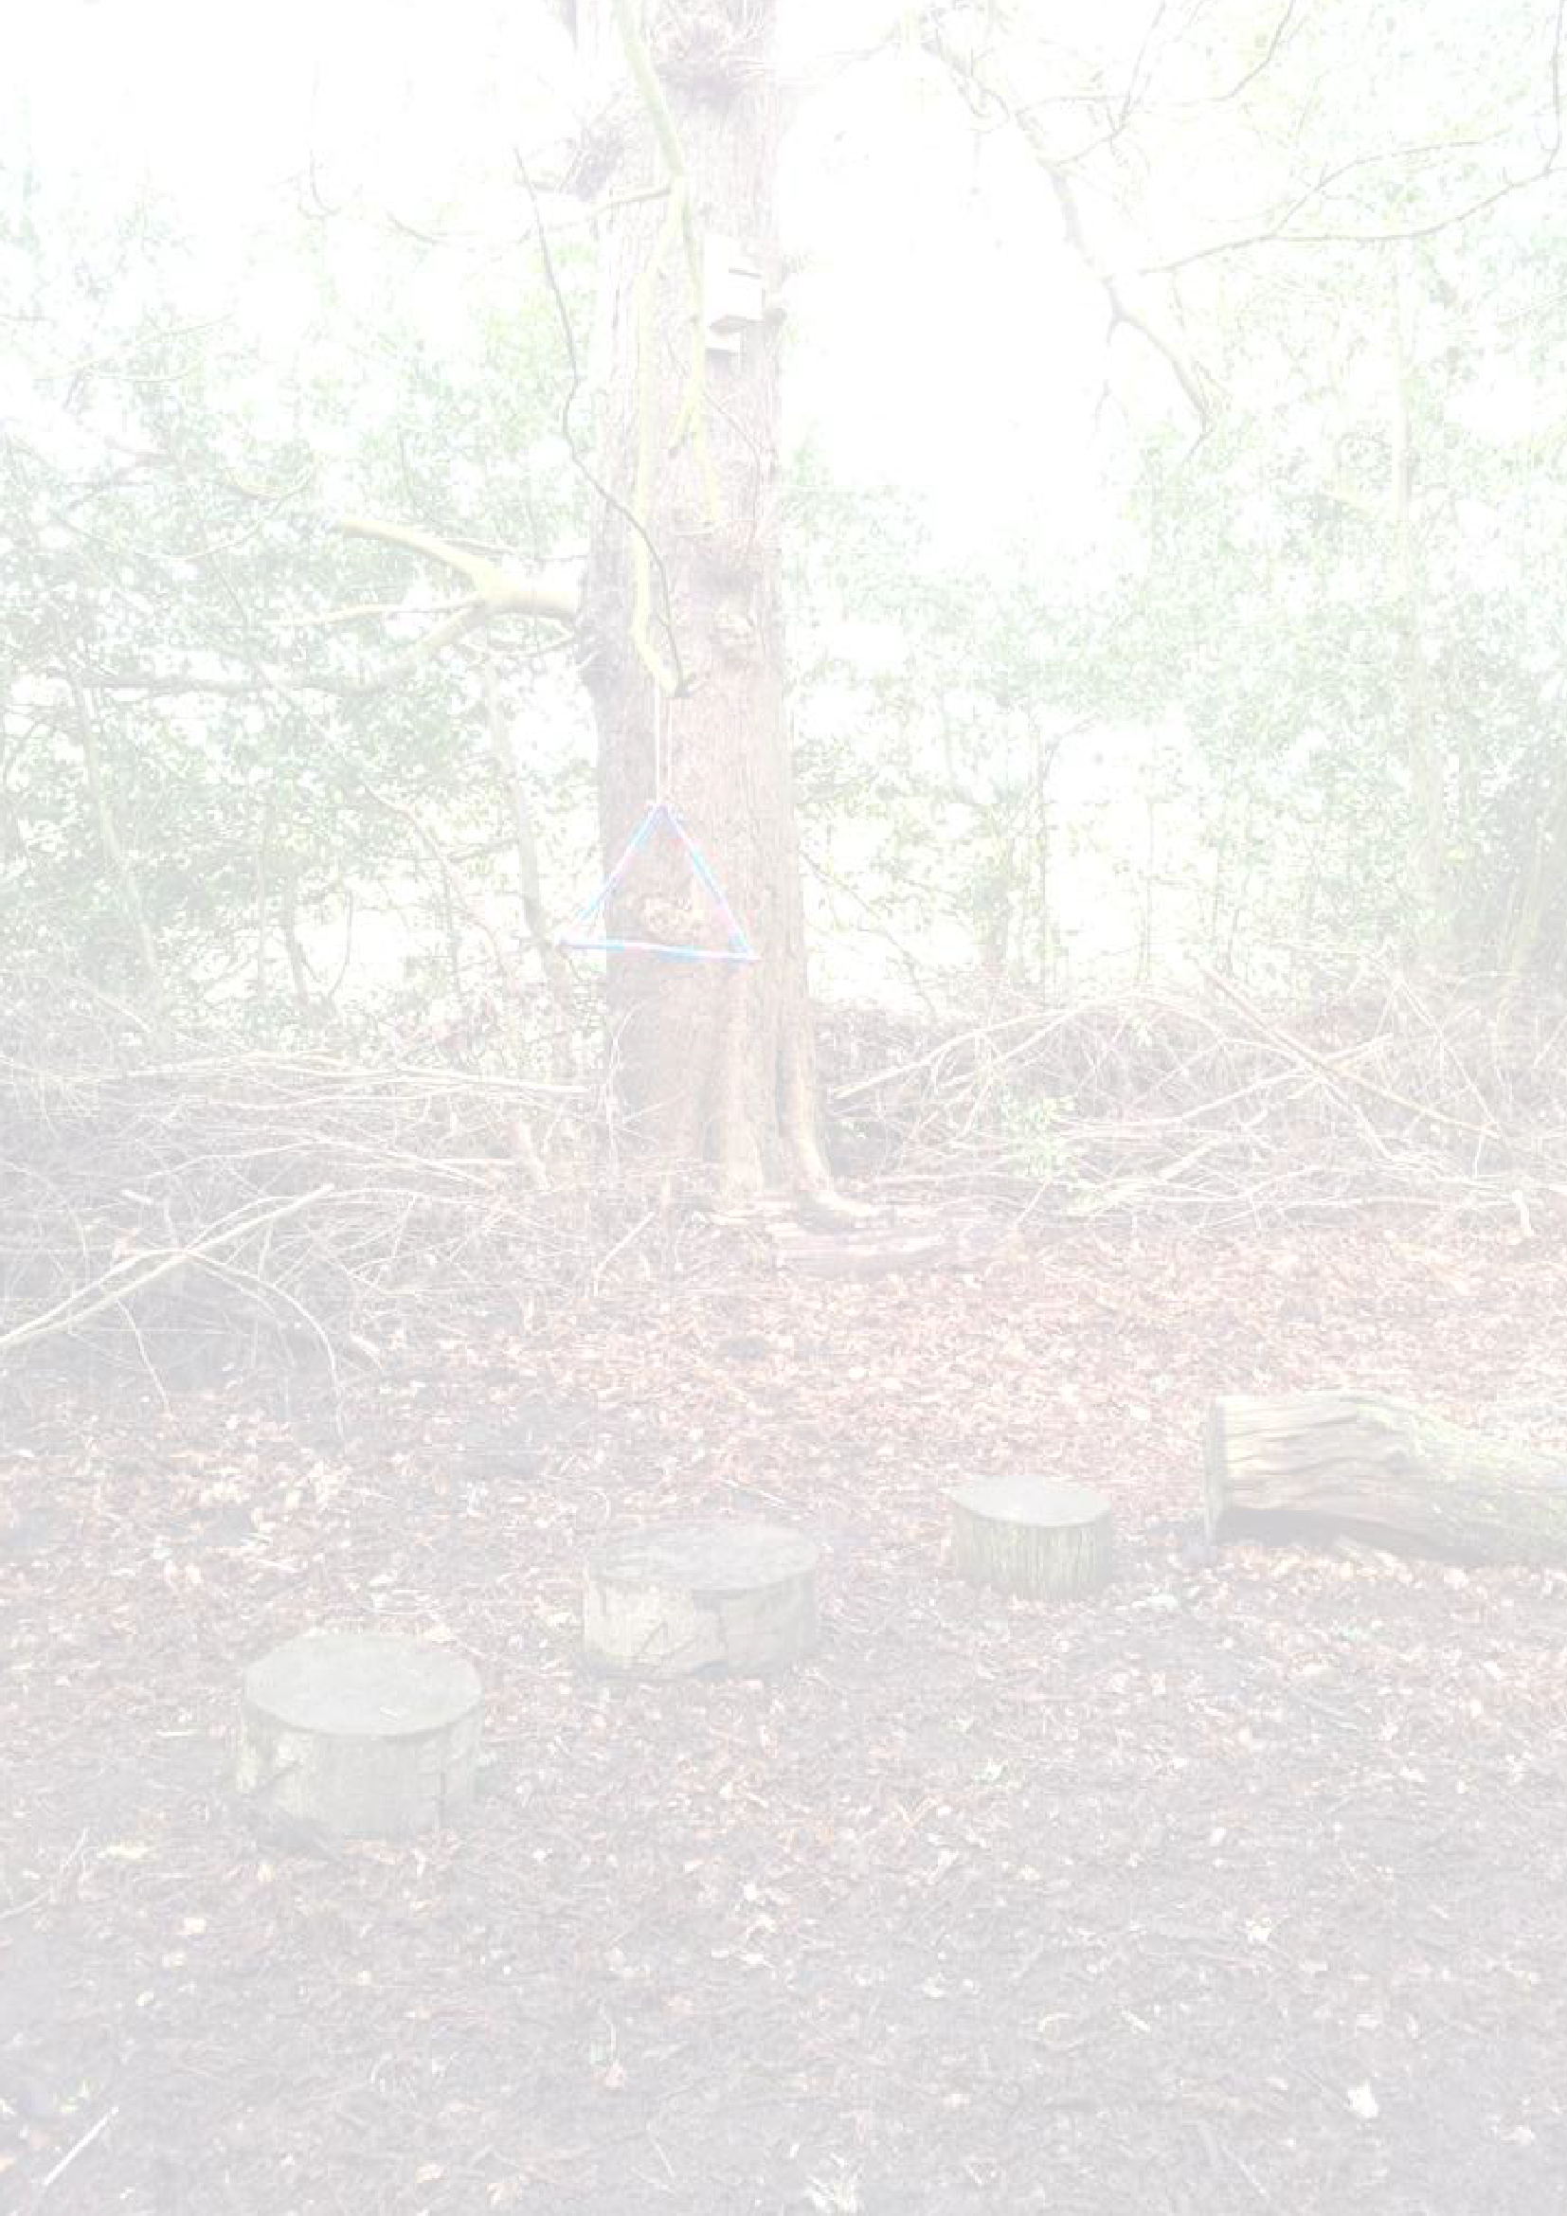
  - Take the 3rd left off Altrincham Road (you will see a large black sign for the school) where you will be met by a member of staff
Styal Primary Forest School Handbook

13
  - Continue down the cobbles and round the back of the school, keep going until you can go no further
  - Grid reference - SJ 83390 83496
- An additional adult is to ensure that the rest of the group are safe and away from any dangers.
- Where appropriate the next of kin should be informed as soon as practicably possible after the incident. The school office is responsible for doing this.
- The school office will inform Mrs Boardman, the school’s headteacher, (or another member of SLT) as soon as they are able to. Following this the landowner of the site should also be informed as soon as possible.
- An incident report must be filled in on site if possible and then logged when back at school.

Uninvited person/stranger
In the event of an intruder on the site they will be challenged and asked to leave politely. If they refuse to do so and the Forest School leader feels that the children are at risk then the group will be evacuated from the site. If a child is involved then the police should be called and the child/children involved should be removed from the situation and made to feel safe. Parents/guardian of the child/children should be briefed by the Forest School leader asap and the Welfare Officer should also be consulted in order to gain advice.

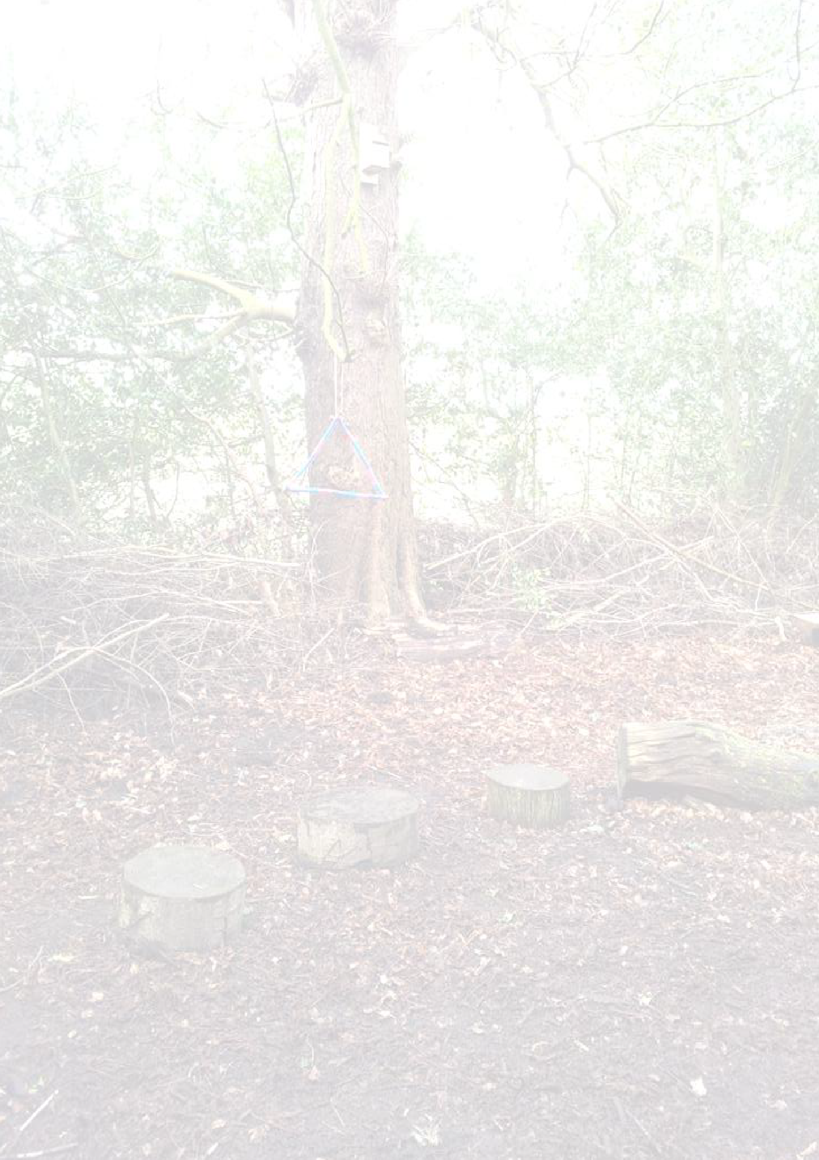
Dogs
Styal Primary Forest School Handbook

14

In the event of a dog entering our Forest School area the children will act as they have been taught to:
  - Call out ‘dog’ to warn others (especially those who are afraid of dogs)
  - Stand still with arms crossed over the chest and head down
  - Stay in that position until the dog has gone

Missing Child
In the event of a missing child the Forest School leader will call ‘1,2,3 where are you?’ If the child doesn’t appear then the immediate vicinity should be searched. The school office will be informed immediately and this information will then be passed on to Mrs Boardman, the school’s headteacher, who will then decide what action to take, including whether to phone the police and parents.

Death / Serious Injury
In the event of death or serious injury, First Aid procedures will be followed. An adult will remain with the casualty whilst another adult removes the rest of the group, ensuring that they are safe. The school office and Mrs Boardman, the school’s headteacher, will be informed immediately who will notify the emergency services and the parents respectively. The school’s Critical Incident Policy will be followed.

N.B. No-one in the group should speak to the media. The names of those involved in the incident should not be given to the media as this could cause distress to their families. Any enquiries from journalists must be referred to the head teacher.

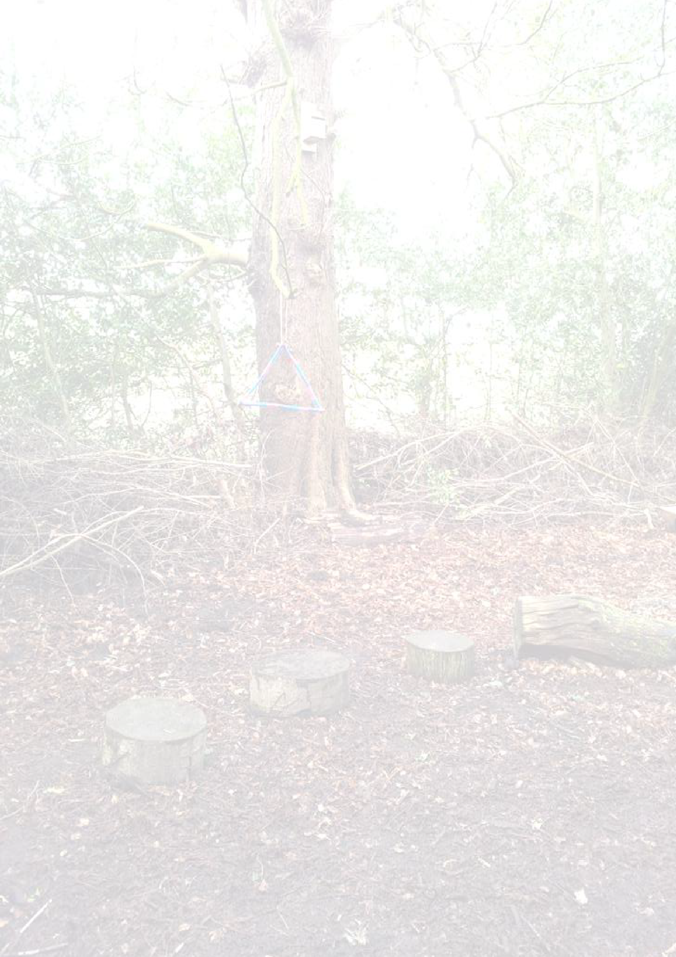
Risk Assessment Guidelines
Styal Primary Forest School Handbook

15
A site safety sweep will be carried out by the Forest School leader before every session (Appendix 1).
A general risk assessment will be carried out four times a year to coincide with the change of seasons.
Additional risk assessments will be carried out for children whose behaviour or medical condition demands them.

The risk assessment process is as follows:

- Look for the hazards
- Decide who might be harmed and how this might happen.
- Evaluate the risks and decide whether the existing precautions are adequate or whether more should be done.
- Record our findings
- Review our assessments and revise them if necessary.

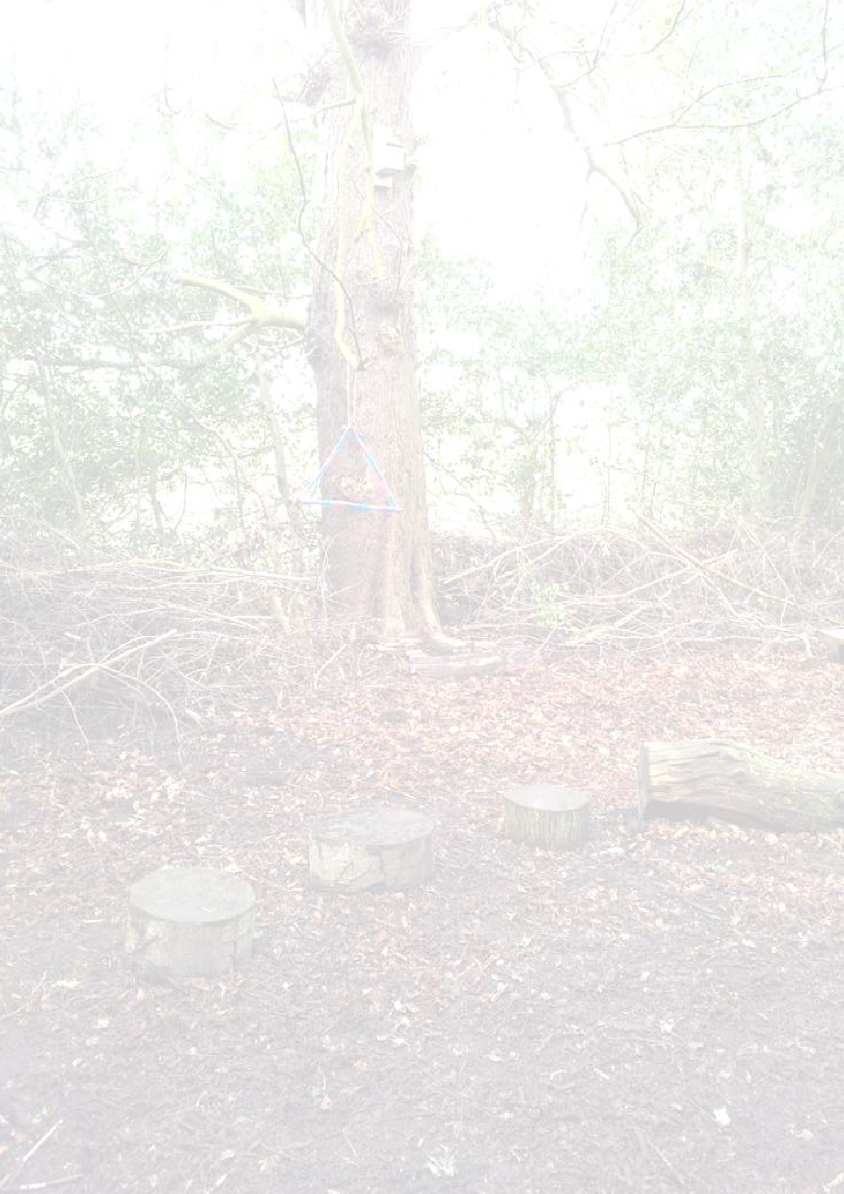
Environmental Impact Assessment
Styal Primary Forest School Handbook

16
We aim to engender a high level of respect for the natural world and encourage everyone who is involved to make good decisions about their environment. By operating in a way that minimises waste, optimises recycling and promotes the reuse of materials we hope to demonstrate and encourage a wider respect for the environment, as well as an understanding that all produce and waste is linked to the health of our planet as a whole.

On site we will follow practices that; minimise the impact on wildlife through being mindful of what we are doing; show an awareness of disturbing habitats; assess what we are leaving behind and if we are causing any long-term damage. Before leaving our site, we will ensure that any litter is collected and disposed of suitably in order to adhere to our ‘Take only photos, leave only footprints’ motto.

Minimising Impacts

Activity | Impact | Mitigation
Collecting Wood | Dead wood is important to any woodland ecology as it has a multitude of uses, from homes for mini beasts to beds for fungi, so a lack of it is bad for any woodland habitat. | Limit the frequency of fires and evaluate the amount of dry, dead wood before having a fire.  Collect only the minimum amount required for any given fire.  Reserve specific areas for dead wood  conservation.
Fires | Changes in soil chemistry can lead to increases in PH levels, carbon, phosphorous, etc. which  can be harmful to some | Designate a fixed location for the fire.  Ensure that all fires are extinguished fully before  leaving the site.

plants, whilst other essential nutrients may be depleted.
Fire can travel underground to roots even after appearing to
be extinguished.
Cooking | Food waste may attract animals to the site or increase numbers of certain species, potentially leading  to adverse changes in  biodiversity. | Take all left-over food back to school in a bin bag for suitable disposal.
Tree Climbing, Shelter Building &  Swings | Damage to trees. | Restrict these activities to suitable trees that will  tolerate them.
Collecting Natural Materials | Damage to plants - some plants are far more sensitive to losing their leaves or flowers than others and different  seasons affects this too. | ‘No picking, no licking’ motto applies at all times. Ensure that only fallen leaves or flowers are collected.
Styal Primary Forest School Handbook

17

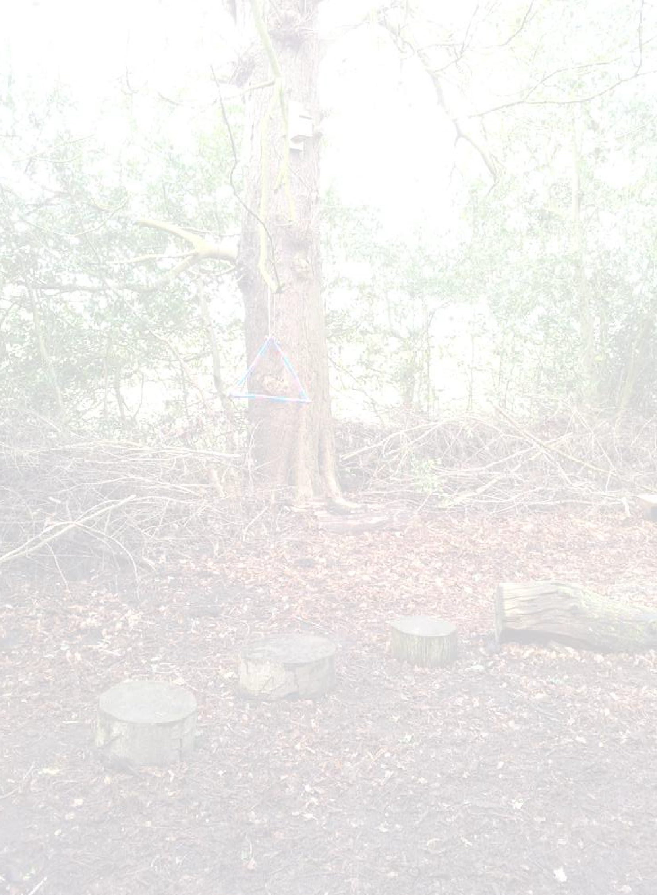
Styal Primary Forest School Handbook
18

Clothing List for Children

Styal School will provide all children with:
  - Waterproof trousers for years 1 – 6
  - Waterproof dungarees for Reception
  - Waterproof jackets
  - There will be an assortment of spare wellingtons and spare clothes for those children who do not have them provided by their parents – we do not want clothing to be a reason for any child to be excluded from their Forest School session.

We will ask parents to provide their child with:
  - Wellingtons / walking boots (however school will have spares)
  - Woolly hat / gloves
  - Sun hat and cream
  - Fleece or additional layer

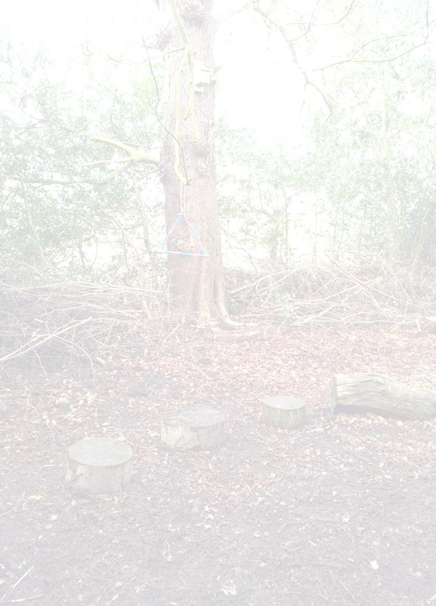
Travel Policy
Styal Primary Forest School Handbook

19

There are no travel arrangements involved as the Forest School area is situated next door to Styal Primary School.

Designated Person

Miss Tompkins / Miss McClendon is the designated person who will take responsibility for each Forest School session.
Although the Forest School leader has overall duty of care for the children in Forest School, all adults present are required to take reasonable steps to ensure that all children are safe.
The Forest School leader has a Paediatric Outdoor First Aid qualification and will be responsible for taking the appropriate First Aid equipment and medication to every session.
The Forest School leader will always carry a mobile phone and know what to do in case of an emergency.
The Forest School leader will carry out a sweep of the site before each session.
The Forest School leader is responsible for showing the children how to use tools safely and appropriately.

Using and Storing Tools
Styal Primary Forest School Handbook

20

Bush-craft knives are stored in a lockable box. The Forest School leader will have access to one key and a spare will be kept in the school office (locked in the key cupboard).
The remaining tools are stored in the tool holdall (which is kept in the locked Forest School Shed, located at the back of the Reception classroom when not in use).
Tools must be cleaned at the end of each session – the children will be taught how to do this safely. The FS leader will thoroughly clean and oil all tools once a week (when they are in use).
Tools are counted in and out and the children know that they are never allowed to help themselves.
Tools are given out for a purpose and all adults should model their correct use, storage and transportation at all times.
Billhooks and bow saws must only be used in the designated tool area (demarcated by a blue rope).
Potato peelers and bush-craft knives are only to be used when the child is seated around the base camp.
Secateurs must only be used on a 1:1 basis when a child has been asked to prune or cut something.

Potato peelers/bush-craft knives – for peeling and sharpening sticks 1:4 ratio
Only to be used with the forest school leader
A protective glove must always be worn on the hand not holding the tool Only to be used when sitting around base camp
Always cut away from the body
Support the wood on the same side knee as the hand holding the knife (e.g. knife in left hand, supporting knee is the left knee)
Ensure fingers are clear from the blade
When walking with peelers keep arm to the side and point down

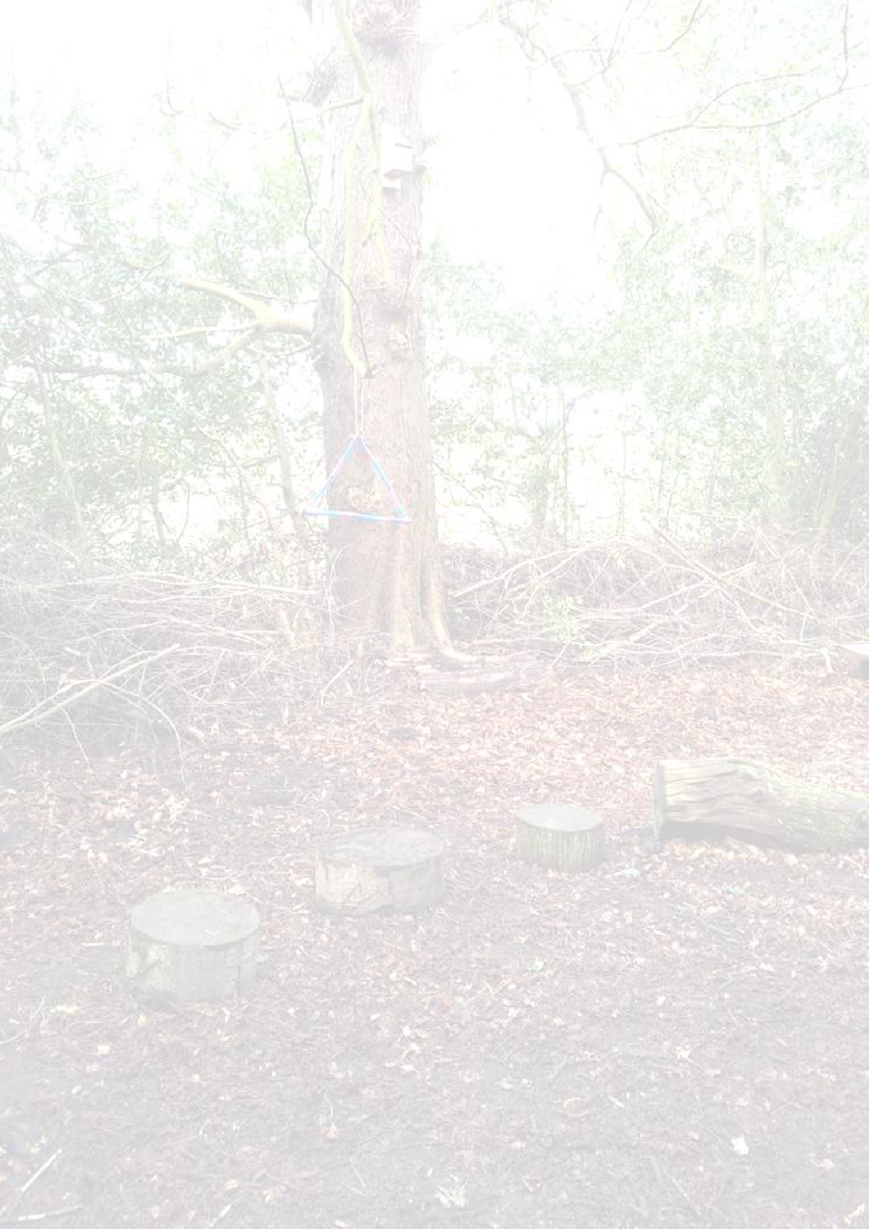
When knives are not in use make sure that they are folded
Styal Primary Forest School Handbook

21
Children will be taught to use the safety lock on the knives correctly

Secateurs – for cutting and pruning 1:2 ratio
Only to be used with the forest school leader
A protective glove must always be worn on the hand not holding the tool Ensure fingers are clear from the blade
When carrying ensure blades are locked closed and pointing towards the floor

Bow saws – for cross-cutting wood up to 12cm diameter 1:2 ratio
Only to be used with the forest school leader Only to be used in designated tool area
A protective glove must always be worn on the hand not holding the tool Keep hands away from blade
Ensure the blade is covered when not in use
Must always be returned to the holdall when not in use Safe temporary storage is hung on the saw horse

Pruning (Pull) Saw – for cutting wood less than 12cm diameter 1:2 ratio
Only to be used with the forest leader Only to be used in the designated area
A protective glove must always be worn on the hand not holding the tool Keep hands away from blade
Ensure the blade is folded when not in use
Must always be returned to the holdall when not in use

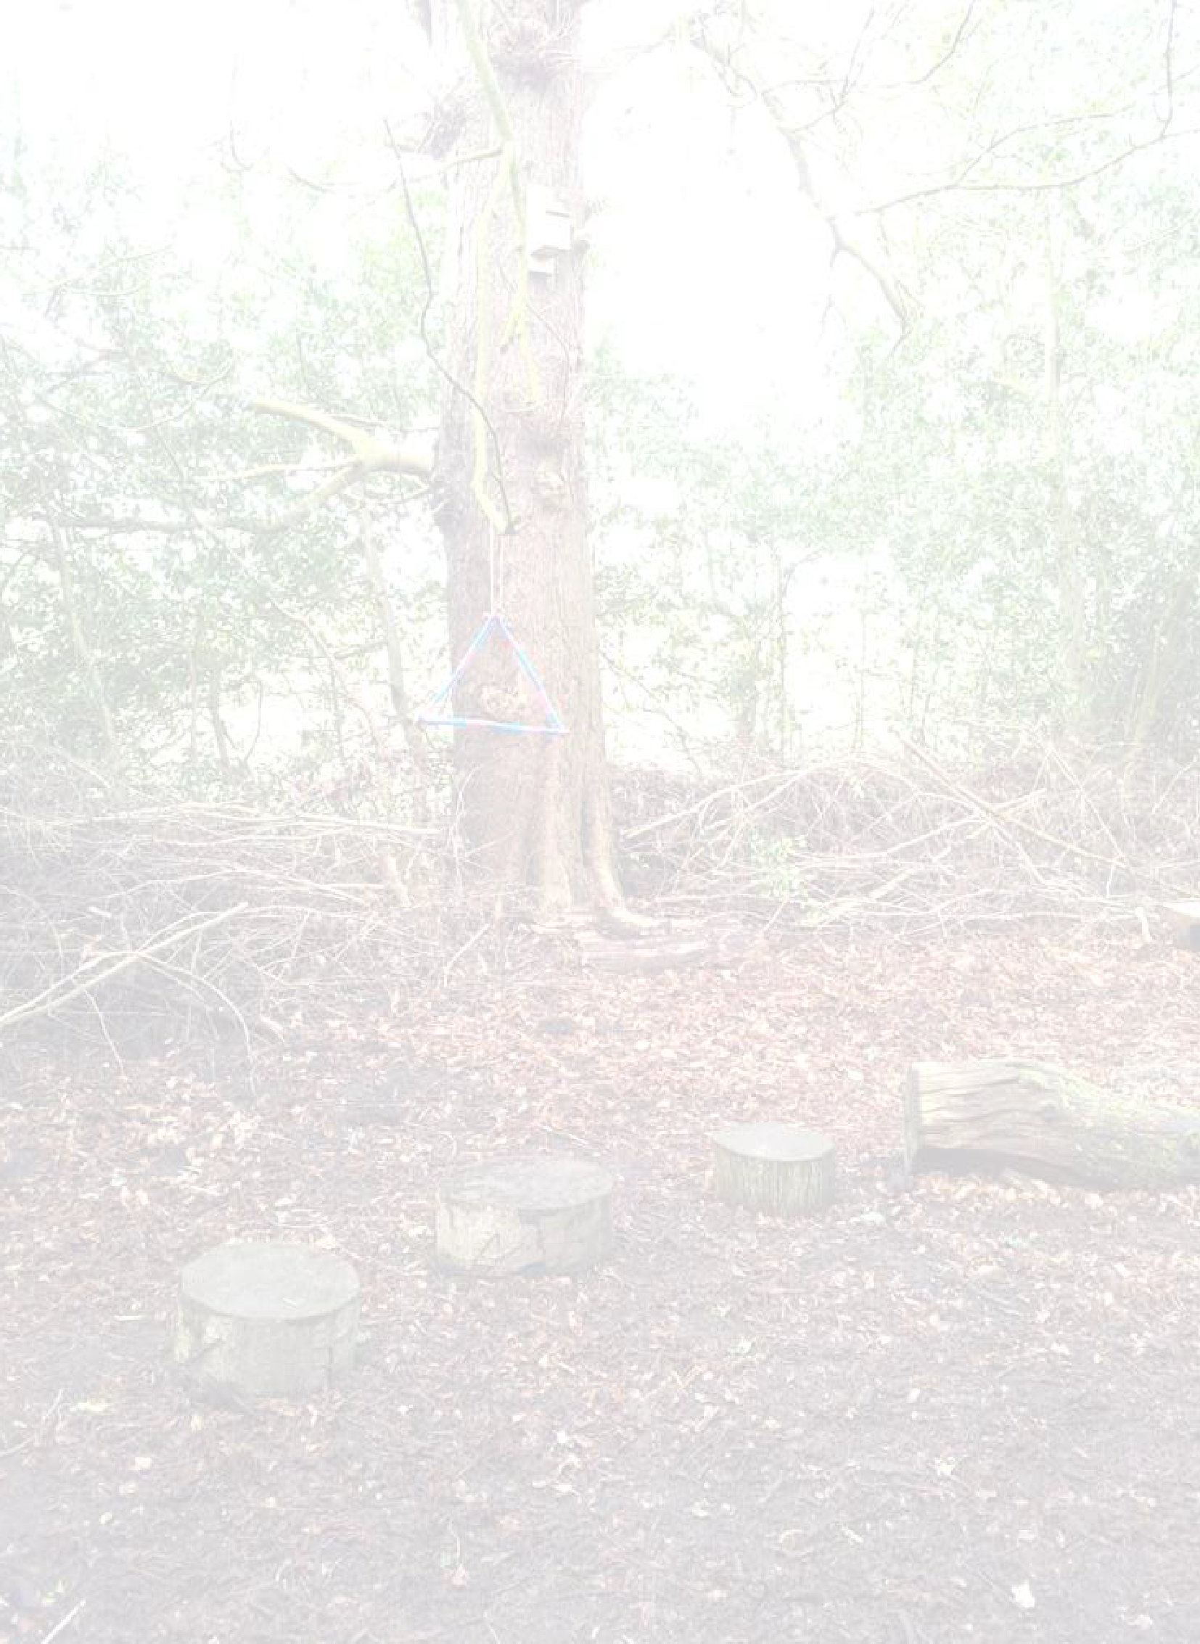
Styal Primary Forest School Handbook
22

Bill hook – used for cleaving 1:2 ratio
Only to be used with the forest leader Only to be used in the designated area
Must always be returned to the holdall when not in use.

Poor Weather Conditions

Forest School sessions will take place in most weather conditions. Children must be dressed appropriately for the weather.
Forest School may not take place if the weather conditions are considered to be dangerous; this may include high winds, thunder storms and extreme cold.
We will use the BBC weather online forecast to make judgments about the expected conditions. The Forest School leader will decide if the weather is appropriate for the session to go ahead.
When it is wet a shelter will be built immediately so that there is a sheltered area that is available from the start that can be used.

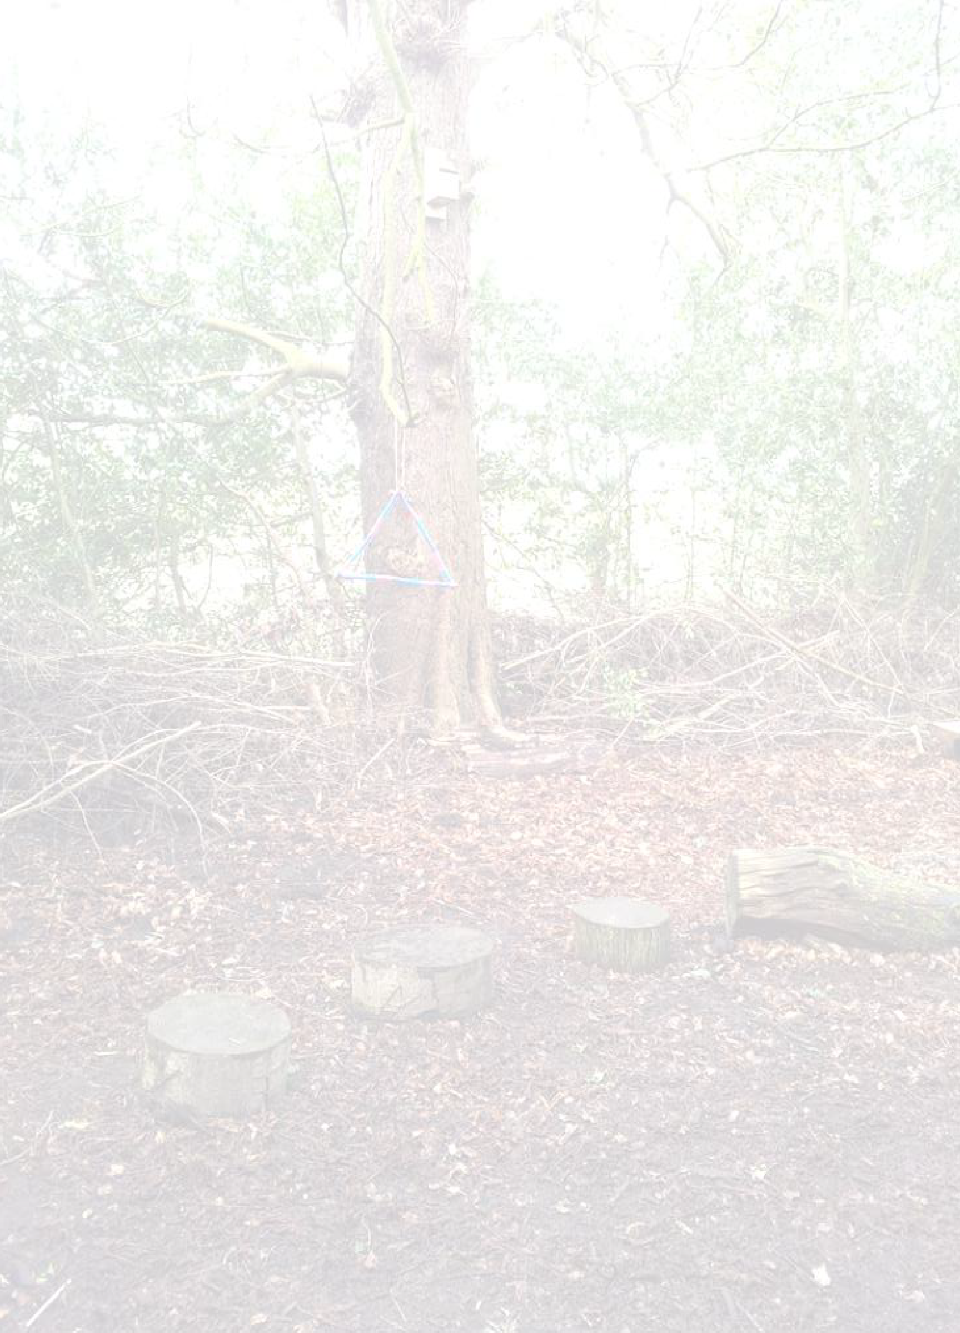
Appendix 1
Styal Primary Forest School Handbook

23
Safety Sweep

Date: |  | Time: |  | Weather:
Name of Forest School Leader:
Checklist | Yes/No |  | Comments
Weather effects
Vandalism
Low branches
Fallen branches
Protruding thorns
Nettles/brambles
Slippery areas
Needles
Broken glass
Standing water
Boundary fence
Tool area roped off
Litter
Equipment ready
Other hazards

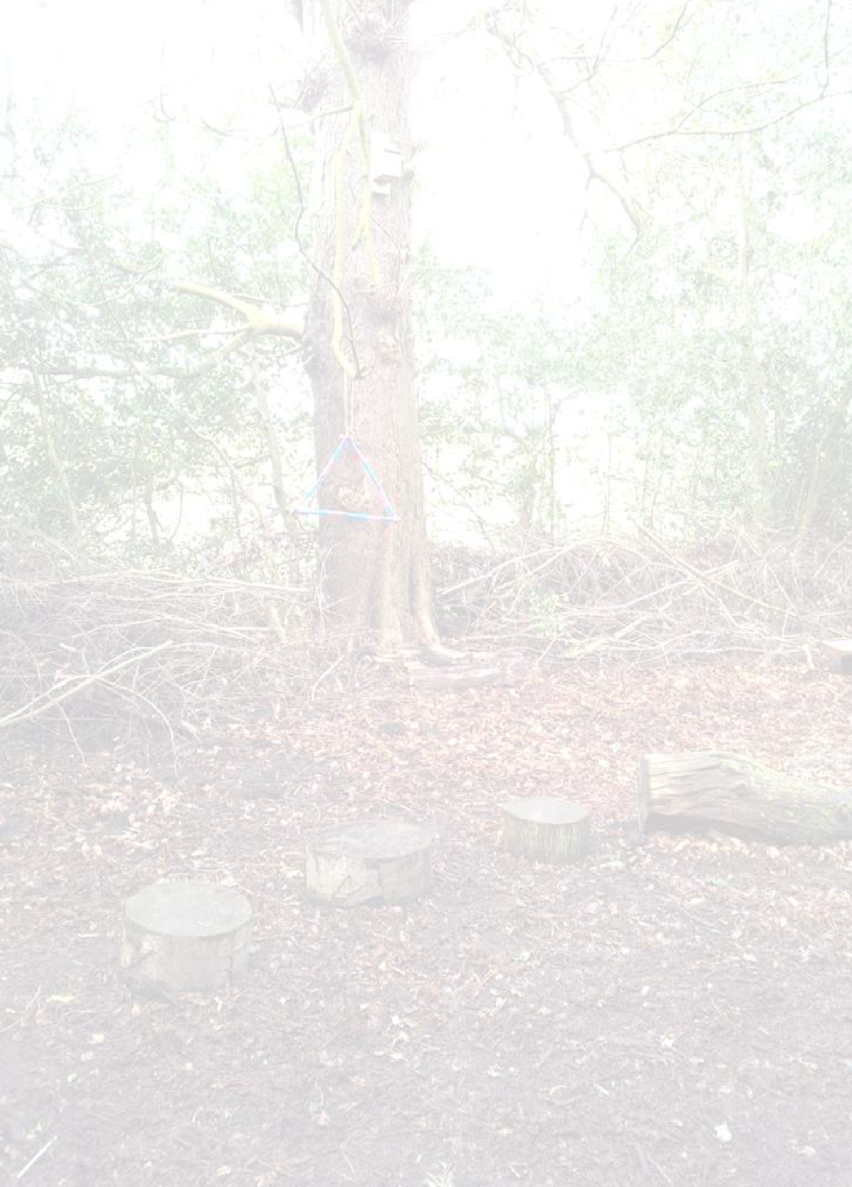
Appendix 2
Styal Primary Forest School Handbook

24

Risk Assessment of Woodland Area

Date assessed _______________ Signed ___________________

Hazard | Potential Harm | Existing measures / New measures | Who will do it?  When? | Risk Level L, M, H
Very cold, hot, wet or windy weather | Exposure and dehydration, hypo/ hyperthermia | Advise all to wear appropriate outdoor clothing.  Wear sun cream and sun hat if very hot.  Leave woodland in high winds with falling branches.  Area under leaning trees or loose branches to be cordoned off. | LJ / AT to assess the weather prior to session. | M
Poisonous or thorny plants, berries or fungi | Poisoning, stings, scratches, rashes and  sickness, infected wound and damage to clothing | Inform all children of the promise – No picking, no licking.  All to be briefed on contact with plants.  Keep arms and legs covered at all times.  Advise to clean hands before eating or drinking.  Advise to wear appropriate clothing. | All adults during each session. | H
Slippery/ muddy or uneven underfoot | Sprain, fracture or concussion | Advise group to wear appropriate outdoor footwear.  Adults to identify areas appropriate to the access needs of the group. Advise all to walk carefully. | All adults during each session. | M
Tree roots and stumps | Tripping | Inform all to take care in woods. No running reminder applies at all times. | All adults during each session. | M

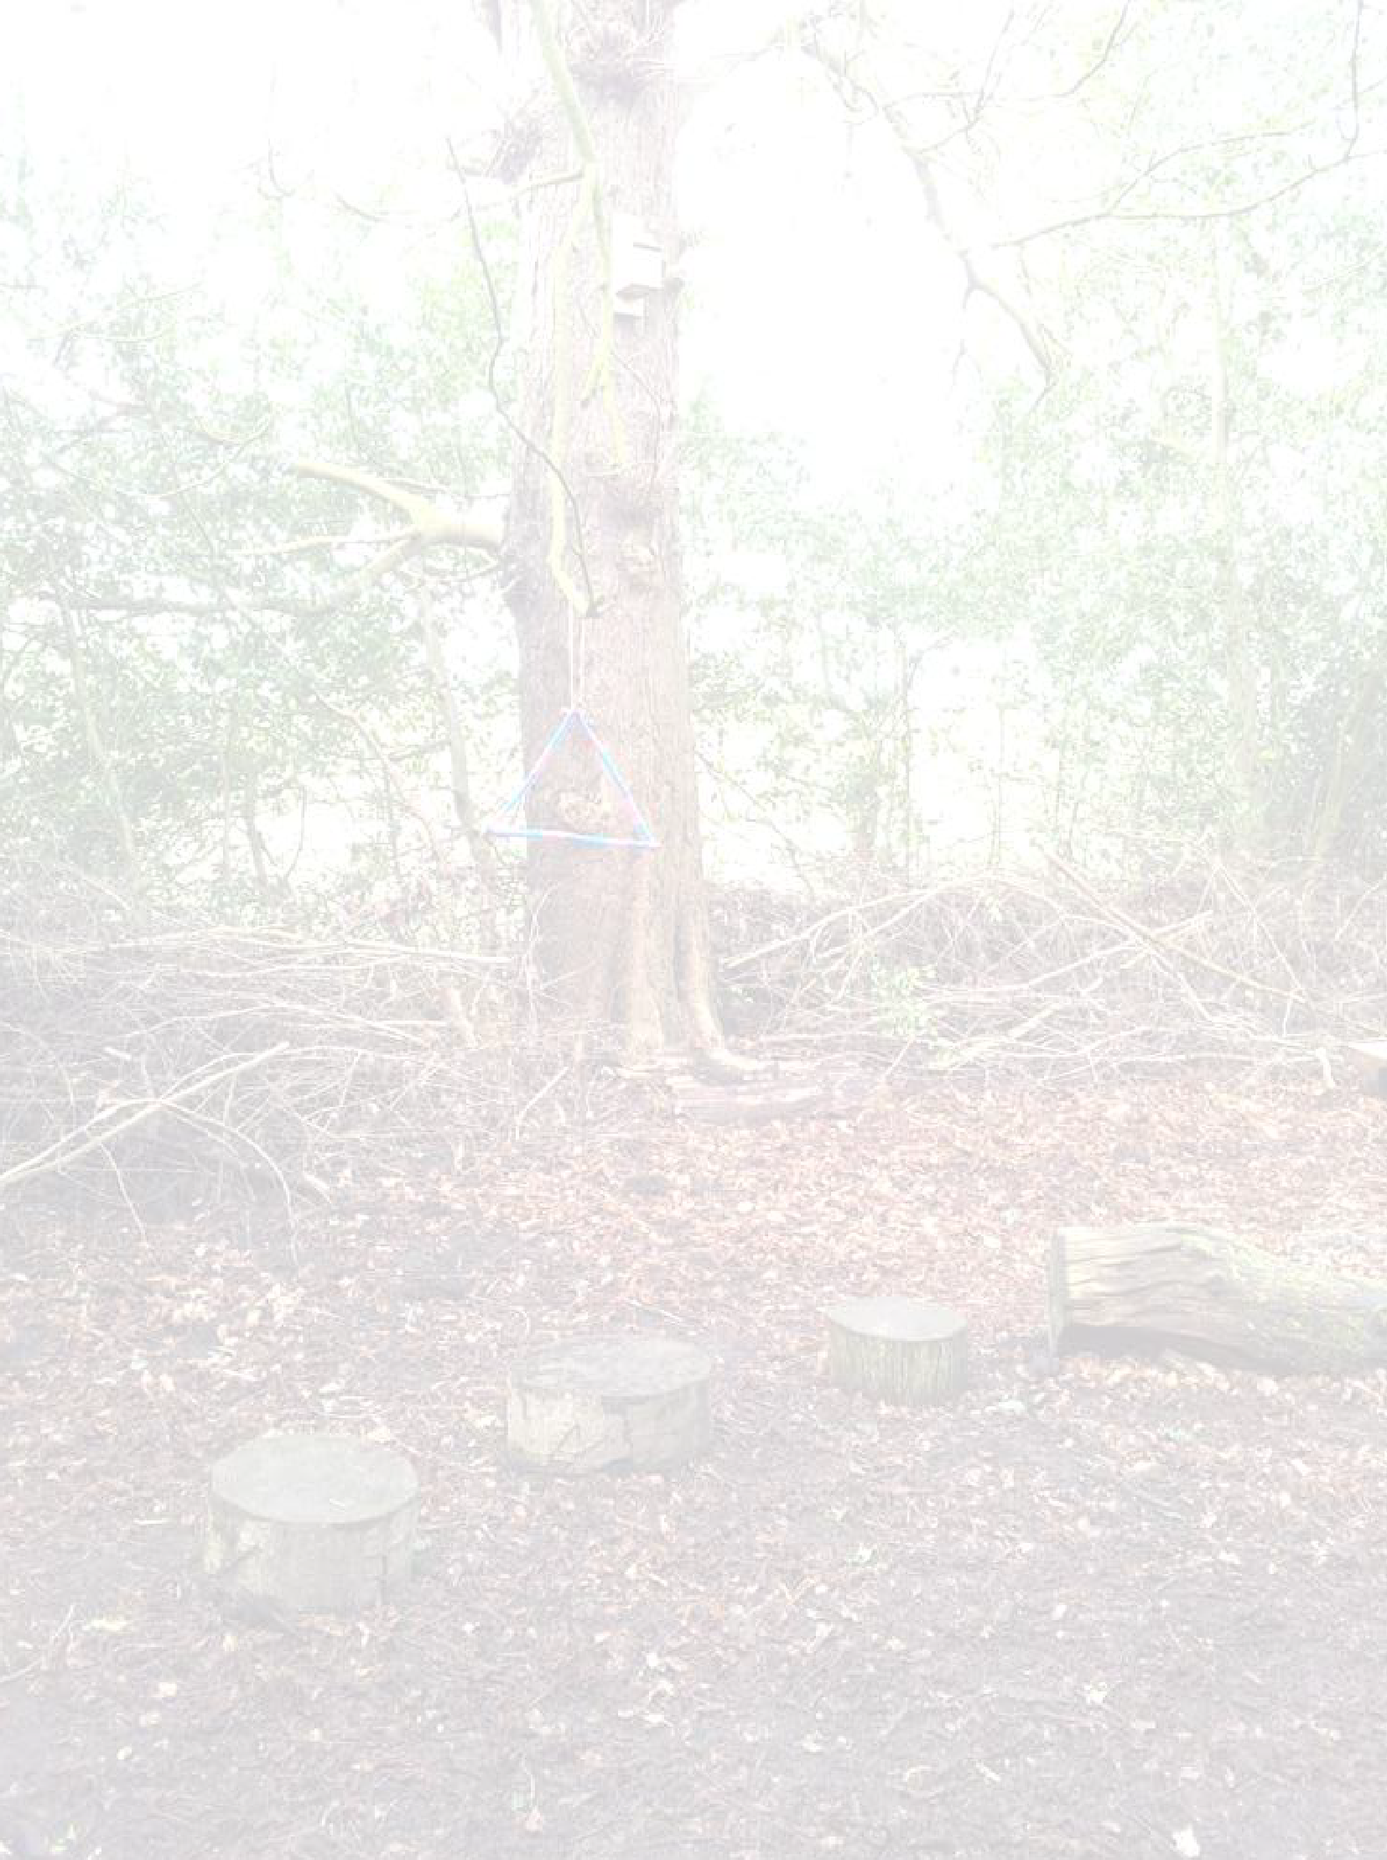
Styal Primary Forest School Handbook
25

Hazard | Potential Harm | Existing measures / New measures | Who will do it?  When? | Risk Level L, M, H
Tree branches | Branches falling, children falling. | Forest School leader sweep. Remove all low hanging branches. | LJ / AT  Prior to session. | M
Animals and public present | Unwanted attention from animals, confrontation. | Encourage all children to keep quiet and still if dogs approach them.  Remind them not to talk to strangers. | All during each session. | M
Missing child | Exposure, injury, panic and shock. | Walk the boundaries with group. Highlight boundaries using blue rope. Staff familiarise themselves with Lost or Missing Person Procedure | All during each session. | H
Sticks/ Stones | Hitting and throwing | Inform children of rules.  Use a stick no longer than your arm. No hitting. | LJ / AT  At the beginning of each session. | M
Faeces | Contamination | During sweep, remove any faeces. | LJ / AT  Prior to each session. | M
Debris / rubbish | Glass, drug use, metals. | Ask children not to pick up rubbish, but instead to inform an adult if they find something.  Adult to remove safely. | All adults.  Prior to and during each session. | M
Fire | Burns, sparks. | Keep a clear space free from equipment or undergrowth around the fire area.  Have extra water available to put out fire.  Have burns kit, heat-proof gloves and fire blanket available. | LJ / AT  Reminder during each session. | H
Food preparation | Food poisoning, allergies. | Check medical forms for allergies. Ensure all food is stored correctly prior to cooking.  Ensure all children use hand sanitizer before cooking.  Ensure all cooking equipment is clean. | LJ / AT  and all adults during each session. | H

Hazard | Potential Harm | Existing measures / New measures | Who will do it?  When? | Risk Level L, M, H
Stinging and biting insects | Stings leading to allergic response. Tick bite leading to Lyme disease | Brief group on potential for bee and wasp stings and possibility of ticks in the woodland.  Check area for nests, avoid contact, first aider always on site, seek medical aid (999) if anaphylactic shock or adder bites are present.  Ask about any history of allergic responses.  Ask group to check skin for any bites at home and if rash, red halo, or flu type symptoms occur go to doctor.  Advise to keep arms and legs covered. | All adults during session. | H
Tools | Cuts, grazes, amputation. | Tools stored away in locked FS Shed.  *See separate risk assessment for each tool available in Forest School handbook.  Strict supervision, correct use of tools. | LJ / AT  During each session where there is a tool-based activity. | H
Trees | Falls out of trees | First aider on site at all times, support children to manage their own risks. 1:1 ratio during tree climbing. | All adults during each session. | M
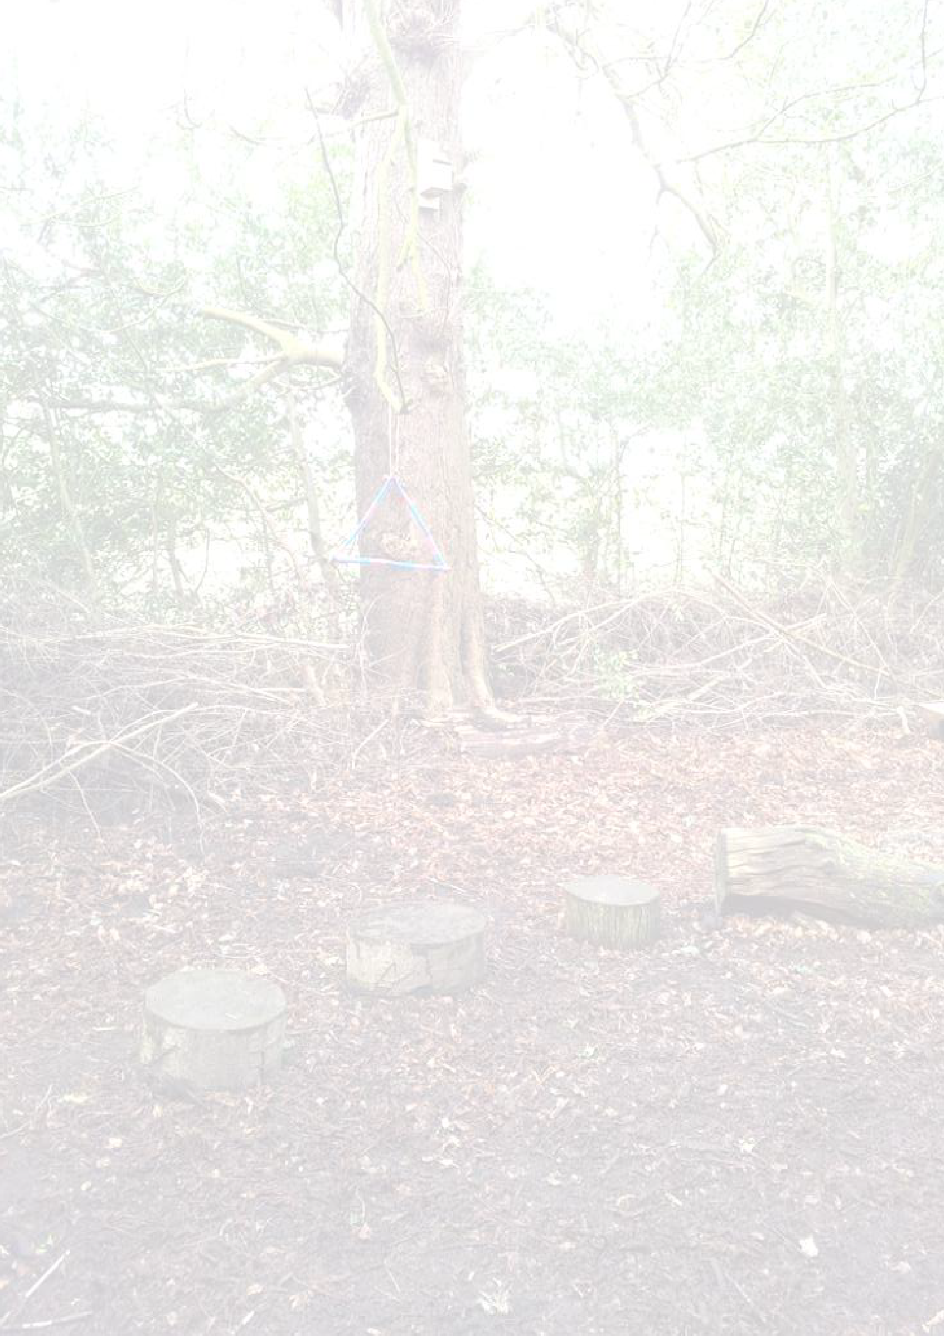
Styal Primary Forest School Handbook

26

